**FY 2018 Data Quality Assessment**

aderonke orefuye FOR DEVTECH systems, inc. / USAID

Health Initiatives for Safety and Stability in Africa (HIFASS) Local OVC Partners in Nigeria 3 (LOPIN 3)

Report Submitted: September 28, 2018

*This page is intentionally left blank.*

**Table of contents**

ACRONYMS 1

1 EXECUTIVE SUMMARY 1

1.1 INTRODUCTION, PURPOSE and METHODOLOGY 1

1.2 FINDINGS 2

1.3 ACTION PLAN 4

2 Introduction and purpose of the DQA 5

2.1 DATA QUALITY STANDARDS 6

2.2 OBJECTIVES OF THE DQA 6

2.3 INDICATOR ASSESSED 7

2.4 PERIOD OF THE DQA 7

2.5 THE LOPIN 3 ACTIVITY 8

3 METHODOLOGY 9

3.1 SAMPLING METHODOLOGY FOR SITE SELECTION 9

3.1.1 INCLUSION CRITERIA: 9

3.1.2 EXCLUSION CRITERIA: 10

3.2 SAMPLE SIZE 10

3.3 SELECTION OF BENEFICIARY FOLDERS AND FORMS FOR OVC INDICATOR REVIEW AT SITES 11

3.4 DATA COLLECTION FOR VALIDATION OF THE SELECTED INDICATOR 11

3.4.1 M&E SYSTEMS ASSESSMENT 11

3.4.2 DATA VERIFICATION 12

3.4.3 DEFINITION AND INTERPRETATION OF THE VERIFICATION FACTOR 13

3.4.4 METHODOLOGY FOR CROSS-CHECKS AT THE CBO LEVEL 13

3.5 DQA TOOL 14

3.6 OTHER OPERATIONAL CONSIDERATIONS FOR DQAS 15

3.7 DATA ANALYSIS 15

4 FINDINGS 17

4.1 M&E SYSTEMS ASSESSMENT – SIX FUNCTIONAL AREAS 17

4.1.1 LOPIN 3 CENTRAL M&E UNIT 17

4.1.2 LOPIN 3 STATE-LEVEL M&E UNIT 18

4.1.3 LOPIN 3 SERVICE DELIVERY LEVEL (CBOs) 21

4.2 DATA QUALITY STANDARDS 24

4.2.1 VALIDITY 24

4.2.2 RELIABILITY 28

4.2.3 PRECISION 28

4.2.4 TIMELINESS 29

4.2.5 INTEGRITY 30

5 Action plan for LOPIN 3 31

5.1 ACTION PLAN FOR LOPIN 3 CENTRAL LEVEL 31

5.2 ACTION PLAN FOR LOPIN 3 STATE LEVEL 32

5.3 ACTION PLAN FOR LOPIN 3 CBO LEVEL 33

6 Limitations and Constraints 34

7 Conclusions 35

8 Annexes 36

8.1 LIST OF SITES VISITED AND LOCATIONS: LOPIN 3 DQA 36

8.2 STEPS FOR DATA VERIFICATION USING THE MEASURE EVALUATION TOOL 36

8.3 OVC VERIFICATION FACTORS – LOPIN 3 CENTRAL, STATE AND CBO LEVELs 37

8.4 DIAGRAMMATIC REPRESENTATION OF CROSS-CHECKS AT CBO LEVEL 39

8.5 DATA BACKUP MECHANISMS IN EBONYI state CBOs 40

8.6 DATA BACKUP MECHANISMS IN CROSS RIVER STATE CBOs 40

8.7 PERFORMANCE INDICATOR REFERENCE SHEET (PIRS) 41

8.8 LIST OF DOCUMENTS, DATA, AND STANDARD OPERATING PROCEDURES REVIEWED 45

8.8.1 LIST OF LOPIN 3 DATA AND DOCUMENTS REVIEWED 45

8.8.2 LIST OF LOPIN 3 BLANK FORMS REVIEWED 45

8.8.3 LOPIN 3 SOP/GUIDELINES AND OTHER DOCUMENTS REVIEWED 45

8.9 LIST OF INDIVIDUALS INTERVIEWED DURING THE LOPIN 3 DQA 46

**LIST OF TABLES**

*Table 1. Data Quality Standards and Operational Definitions* 6

*Table 2. Schedule for LOPIN 3 DQA* 8

*Table 3:* *List of Central, State, and CBO Offices / Sites visited for the LOPIN 3 DQA* 10

*Table 4. Data Coverage for LOPIN 3 DQA, by Level* 11

Table 5: Cross-Check Findings from LOPIN 3 CBOs in Ebonyi and Cross River States 27

Table 6. Mechanisms for Ensuring Data Integrity Across LOPIN 3 Reporting Levels 30

Table 7. Mechanisms for Ensuring Data Integrity Across LOPIN 3 States 30

Table 8. Action Plan for LOPIN 3 Central Level 31

Table 9. Action Plan for LOPIN 3 State Level 32

Table 10. Action Plan for LOPIN 3 CBO Level 33

Table 11. OVC_HIVSTAT Disaggregates for the Central, State and CBO Levels 37

Table 12. Verification Factors – OVC_HIVSTAT Disaggregates for the Central, State and CBO Levels for LOPIN 3 38

Table 13. Backup Mechanisms Utilized in Ebonyi State CBOs Visited 40

Table 14. Backup Mechanisms Utilized in Cross River State CBOs Visited 40

Table 15: Performance Indicator Reference Sheet for OVC_HIVSTAT 41

*Table 16. List of Individuals Interviewed during the LOPIN 3 DQA* 46

**LIST OF FIGURES**

Figure 1: Data Management Systems Assessment for all LOPIN 3 sites visited – Global Average 3

Figure 2. Spider Graph of M&E Systems Assessment: LOPIN 3 Central M&E Unit 18

*Figure 3. Spider Graph of M&E Systems Assessment: LOPIN 3 Cross River State* 20

Figure 4:Spider Graph of M&E Systems Assessment: LOPIN 3 Ebonyi State 20

Figure 5. Verification Factor: LOPIN 3 Central Level OVC_HIVSTAT Numerator Total and Disaggregates 25

Figure 6. Verification Factors for LOPIN 3 Ebonyi and Cross River States and CBOs, OVC_HIVSTAT Numerator Totals 26

*Figure 7: Average Data Verification Factors by Level of Reporting System for LOPIN 3* 26

Figure 8. Reporting Performance – Results by State and Aggregate of States Results 29

*Figure 9. Tracing and Verifying Reported Totals: CBO via State to Central M&E Unit* 36

*Figure 10. Methodology for Cross-Checks at CBO Level* 39

# ACRONYMS

ADS Automated Directives System (USAID)

ART Antiretroviral Therapy

CACA Catholic Action Committee on HIV/AIDS

CBO Community Based Organization

CMP Change Management Process

CSI Child Status Index

CV Community Volunteers

DATIM Data for Accountability, Transparency and Impact

DDNI Destiny Daughters of Nigeria Institute

DEC Data Entry Clerk

DQA Data Quality Assessment

DQA Data Quality Audit

FG Federal Government

GIS Geographical Information System

HIFASS Health Initiatives for Safety and Stability in Africa

HIV Human Immunodeficiency Virus

HIV/AIDS Human Immunodeficiency Virus / Acquired Immunodeficiency Syndrome

IM Implementing Mechanism

IP Implementing Partner

LACA Local Agency for the Control of AIDS

LGA Local Government Authority (or Area)

LOPIN Local OVC Partners in Nigeria

M&E Monitoring and Evaluation

MEL Monitoring, Evaluation, and Learning

MER Monitoring, Evaluation, and Reporting

MSF Monthly Summary Form

MWASD Ministry of Women Affairs and Social Development

NCF Neighbor Carewell Foundation

NOMIS National OVC Management Information System

OGAC Office of the United States Global AIDS Coordinator

OIF Oten Ita Foundation

OVC Orphans and Vulnerable Children

OVC_HIVSTAT PEPFAR Indicator: Number of children less than 18 years with reported HIV status to implementing partner

OVC_SERV PEPFAR Indicator: Number of beneficiaries served by PEPFAR OVC programs for children and families affected by HIV

PEPFAR President’s Emergency Plan for AIDS Relief

PIRS Performance Indicator Reference Sheet

RC Rhema Care

RDQA Routine Data Quality Assessment

SACA State Agency for the Control of AIDS

SAPR Semi-Annual Program Results

SIDHAS Strengthening Integrated Delivery of HIV/AIDS Services

SMILE Sustainable Mechanism for Improving Livelihoods and Household Empowerment

SOP Standard Operating Procedures

STEER Systems Transformed for Empowered Action and Enabling Responses for Vulnerable Children and Families

TWG Technical Working Group

USAID United States Agency for International Development

VC Vulnerable Children

WCHDI Women, Children Health Development Initiatives

# EXECUTIVE SUMMARY

## INTRODUCTION, PURPOSE and METHODOLOGY

The United States Agency for International Development (USAID)/Nigeria technical offices regularly collect performance data from their Implementing Partners (IPs), and analyze it to make management decisions. Program management requires accurate, reliable, complete, and timely data to facilitate evidence-based decision making. Orphan and Vulnerable Children (OVC) programs among Human Immunodeficiency Virus, Acquired Immunodeficiency Syndrome (HIV/AIDS) affected populations provide need-based and age-appropriate socioeconomic interventions and require data that ensure provision of high-quality services. Since poor-quality data affect conclusions about performance and lead to incorrect decisions, USAID requires that all Missions/Offices conduct regular Data Quality Assessments (DQA), to review (1) strengths and weaknesses of the data, as determined by applying the five data quality standards (i.e., ***validity, reliability, timeliness, precision, integrity***); and (2) the extent to which the data integrity can be trusted in making management decisions.

The Local OVC Partners in Nigeria (LOPIN 3) is one of the USAID/Nigeria’s OVC Implementing Mechanisms (IMs) being implemented by Health Initiatives for Safety and Stability in Africa (HIFASS). In 2017, USAID/Nigeria and the Monitoring, Evaluation, and Learning (MEL) Activity of DevTech Systems, Inc. conducted a joint DQA to validate six months of LOPIN 3 performance data, for the period October 1, 2016, to March 31, 2017. The US President’s Emergency Plan for AIDS Relief (PEPFAR) indicator reviewed was “***number of OVCs served (OVC_SERV)”***, as reported through the National OVC Management Information System (NOMIS). A follow-up DQA was conducted by the MEL Activity in March 2018 to assess the extent to which recommendations from the Fiscal Year (FY) 2017 DQA were executed and the challenges encountered in implementing the recommendations. Action plans were developed for quick execution of the follow-up DQA recommendations based on identified challenges.

In FY 2018, another DQA exercise was conducted in June 2018 to review performance data submitted by LOPIN 3 to USAID for the Semi-Annual Program Results (SAPR) period (October 1, 2017 to March 31, 2018) for the PEPFAR indicator “OVC_HIVSTAT” which is the “percentage of OVC less than18 years old with HIV status reported to the IP (including status not reported), disaggregated by status type.” For this assessment, only the numerator “number of OVC less than 18 years old with HIV status reported to the IP (including status not reported), disaggregated by status type” was assessed because the denominator is no longer collected as part of the OVC_HIVSTAT indicator, it is collected as part of the OVC_SERV indicator.

The DQA was implemented using a purposive sampling methodology in six selected Community Based Organizations (CBOs) in Cross River and Ebonyi states, the respective LOPIN 3 state offices, and the LOPIN 3 central Monitoring and Evaluation (M&E) Unit in Abuja,FCT.

The DQA methodology at all levels included: (1) A review of activity M&E documents, materials, and data, including Standard Operating Procedures (SOP), guidelines, Performance Indicator Reference Sheet (PIRS), and other guiding documents for organizational M&E management, data management, and processing; (2) A review of six months of LOPIN 3 OVC summary reports, and trace and verification of indicator data (including NOMIS data); (3) A review of a subset of source documents (beneficiary forms and household folders), and entries of beneficiaries and households in the NOMIS; (4) Interviews with M&E Officers and personnel; (5) Cross-checks across systems and records; (6) A review of the data applying the five data quality standards (i.e., validity, reliability, integrity, precision and timeliness); and (7) A debrief at each site on the preliminary DQA findings using a feedback form. The DQA team utilized USAID MEASURE Evaluation’s DQA Excel Tool (RDQA multi-indicator version[1]), as well as the USAID DQA checklist[2] to assess the data quality standards.

## FINDINGS

**M&E Systems Assessment**

LOPIN 3 Central M&E Unit: *Strengths*: (1) Availability of trained M&E staff; (2) Availability of the LOPIN 3 M&E data management SOP; (3) Use of a Change Management Process (CMP) to guide changes to data; and (4) Data are being analyzed and used for decision making. *Area for Improvement*: Guidelines are not in place to inform late receipt of reported data from lower reporting levels. *Recommendation:* Update the existing M&E guidelines to include a section that informs late receipt of data from lower reporting levels.

LOPIN 3 State M&E Units: *Strengths*: (1) All state level M&E Officers have received relevant training to carry out their assigned responsibilities; (2) Availability and use of the LOPIN 3 M&E data management SOP; (3) Availability of the PIRS for the indicator being assessed; (4) The NOMIS database is being used for reporting; (5) Multiple data backup processes are in use e.g., hard drive and cloud; and (6) Data are collated, analyzed and presented in charts, tables, etc. to various stakeholders for decision making. *Areas for Improvements*: (1) Timeline for reporting are not adhered to by CBOs in Ebonyi state; (2) Guidelines are not in place to inform late receipt of reported data from lower reporting levels; and (3) Inconsistency in documenting supervisory visits to lower reporting levels in Ebonyi state. *Recommendations*: (1) Ensure compliance of CBOs in Ebonyi state to reporting deadlines; (2) Provide technical assistance to CBOs prior to reporting deadline to identify and resolve issues resulting in late submission of reports; (3) Obtain and implement LOPIN 3 guidelines on late reporting of data from lower reporting levels; and (4) Update records of supervisory visits conducted by M&E unit staff of the LOPIN 3 Ebonyi state office.

LOPIN 3 CBOs*: Strengths*: (1) CBOs have trained M&E staff; (2) Suitable backstop is available to fill-in for the M&E officer when unavailable; (3) The PIRS on the indicator, the LOPIN 3 SOP for data management and national OVC tools are all available and in-use; (4) The NOMIS software is in use and password protected; (5) Beneficiaries folders are stored under lock and key with limited access; (6) Data are backed up routinely using external drive and the cloud; (7) Data are analyzed and used for decision making; (8) Good filing and storage system of beneficiary records; (9) CMP is used when changes are made to reported data; and (10) Written policy available on the storage period for source documents. *Areas for Improvement:* (1) Use of notebooks by CVs to record beneficiary information before transferring to the service forms at Destiny Daughters of Nigeria Institute (DDNI); (2) Limitations in data are not included when data are being disseminated by Rhema Care (RC), Women Children Health Development Initiative (WCHDI), Catholic Action Committee on AIDS (CACA) and DDNI; (3) At CACA and Neighbor Carewell Foundation (NCF), folders of active beneficiary households were not separated from folders of graduated households; and (4) Beneficiary folders were arranged horizontally in the storage cabinets while service forms were not arranged orderly within the folders, making retrieval difficult. *Recommendations:* (1) Build the capacity of CBO M&E staff to include limitations in data when disseminating to stakeholders and to file same for reference purpose; (2) Build the capacity of CBO staff to properly store beneficiary folders by separating active beneficiary households from graduated household folders; arrange folders vertically within the storage cabinets; and arrange service forms orderly within the folders for easy retrieval; (3) Conduct re-fresher training for CVs on completion of data collection tools and discourage the use of notebooks (DDNI).

The general findings on the M&E system assessment for all levels assessed are shown in the spider graph in Figure 1 below. The general areas for improvement for LOPIN 3 are in its data management processes and use of data for decision making. The section on links with the national reporting system shows some gaps which occurred because of parallel reporting channels, i.e., to government and donor agencies. However, there are mechanisms in place to harmonize data at the different levels such as the data harmonization meetings.

Figure 1: Data Management Systems Assessment for all LOPIN 3 sites visited – Global Average

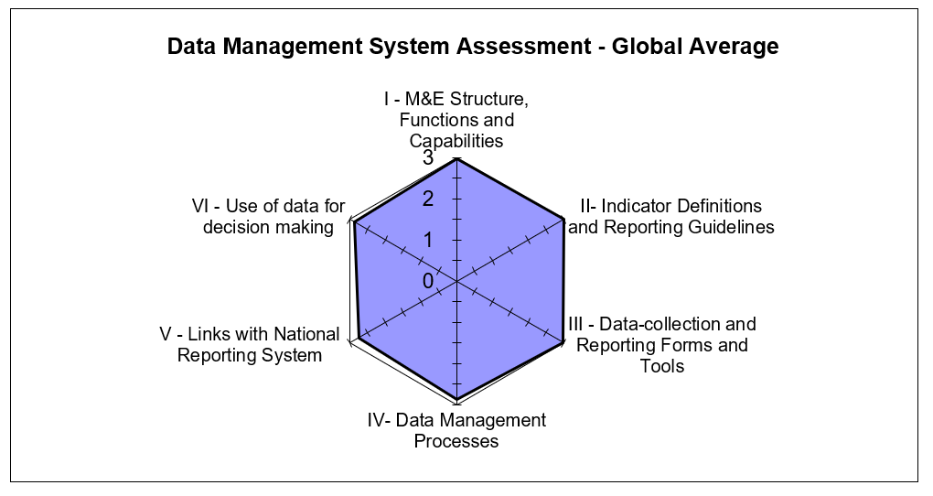

**Data Quality Standards**

Validity*:* *Strengths:* (1) The data collection process adheres to PIRS requirements; and (2) Data reported are for vulnerable children less than 18 years of age disaggregated by their HIV status, and this remains consistent across all CBOs. *Areas for Improvement:* (1) Transcription errors from incomplete entries into the source documents and into NOMIS led to under and over reporting; (2) Errors observed during data verification; (3) Missing data in NOMIS following data export and NOMIS software upgrade; and (4) Incorrect calculation of the totals on the customised LOPIN 3 CSO Vulnerable Household/Children Monthly Summary Form (MSF). *Recommendations:* (1) Improve supervisory efforts with the CBOs to ensure accurate data entry and proper use of the NOMIS; (2) Provide refresher training on the NOMIS software to Data Entry Clerks (DECs); (3) Provide support to CBO M&E Officers to conduct periodic folder audits to resolve discrepancies observed during cross checks; (4) Update NOMIS software to the most recent version to address NOMIS data discrepancies; and (5) Amend the error of summated data in the totals row of the customised LOPIN 3 CSO Vulnerable Household/Children MSF.

Reliability*:* *Strengths*: National OVC reporting tools were consistently used during the reporting period. *Areas for Improvement:* Beneficiary data is first recorded in a notebook at DDNI before being transferred to the service forms. *Recommendations:* In order to reduce transcription errors, CVs at DDNI should be encouraged to record beneficiary information directly into the service forms.

Precision*:* *Strengths*: The NOMIS has individual-level data, providing sufficient detail and precision on number of children less than 18 years with HIV status reported by the IP. *Areas for Improvement:* None. *Recommendations:* There are no specific recommendations related to data precision.

Timeliness*: Strengths*: Data reporting from the CBO level upward is electronic, via NOMIS and is reported to be received in a timely manner at higher levels. *Areas for Improvement:* Untimely reporting by states and CBOs. *Recommendations* (1) Ensure compliance of state and CBO levels to reporting timelines; (2) Review the work load of Community Volunteers (CVs) and DECs to ensure data are ready for submission by the reporting deadline; and (3) Encourage task shifting among CBO staff to ease the workload DECs.

Integrity*:* *Strengths:* (1) Data quality assurance and management at the central and state Levels are thorough and include the use of the NOMIS software, which has password access for confidentiality and built-in error and quality checks, visits to lower levels for supervision and to conduct data quality checks, and the use of e-mail and phone call communication by the M&E staff; (2) Data review meetings are held quarterly during which data quality issues are addressed; and (3) Internal DQAs are periodically conducted. *Areas for Improvement:* None. *Recommendations:* None.

## ACTION PLAN

*Central Level*: (1) Update M&E guidelines to include a section on steps to be taken to address the late receipt of reported data from lower reporting levels; and (2) Amend the error of summated data in the totals row of the customized LOPIN 3 CSO Vulnerable Household/Children MSF.

*State Level*: (1) Ensure CBOs’ compliance in Ebonyi state; (2) Provide technical assistance to CBOs prior to the reporting deadline to identify and resolve issues that resulted in late report(s) submission; (3) Obtain and implement LOPIN 3 guidelines on late reporting of data from lower reporting levels; (4) Review the workload of the CVs and DECs and make necessary recommendations to ease the CBOs’ workload; (5) Update records of supervisory visits conducted by staff of the Ebonyi state Office; (6) Improve supervisory efforts with the CBOs to ensure accurate data entry and proper use of the NOMIS; (7) Conduct refresher training for DECs on the NOMIS software; (8) Ensure all CBOs conduct data quality cross checks between the NOMIS soft copy data and a hard copy Excel NOMIS data before reporting; (9) Provide support to CBO M&E Officers to conduct periodic folder audits to resolve discrepancies observed during cross checks; (10) Build the capacity of CBO M&E staff to include limitations in data disseminated to stakeholders and to file same for reference purpose; and (11) Build the capacity of CBO staff to properly store beneficiary folders by separating active beneficiary households from graduated household folders; arrange folders vertically within the storage cabinets; and arrange service forms orderly within the folders for easy retrieval.

*CBO Level*: (1) Conduct re-fresher training for CVs on completion of data collection tools and discourage the use of notebooks (DDNI); and (2) Update NOMIS software to the most recent version to address NOMIS data discrepancies.

# Introduction and purpose of the DQA

The technical offices of the United States Agency for International Development (USAID)/Nigeria regularly collect performance data from their Implementing Partners (IPs), and analyze it to make management decisions. Program management requires accurate, reliable, complete, and timely data to facilitate evidence-based decision-making and, ultimately, to ensure efficient and effective program implementation. Orphan and Vulnerable Children (OVC) programs among populations affected by Human Immunodeficiency Virus, Acquired Immunodeficiency Syndrome (HIV/AIDS) provide socioeconomic interventions that are need based and age appropriate, and therefore require data to ensure that high-quality services are provided to children and their families. This is even more important in households with an HIV-positive child or caregiver, who will need to receive the appropriate support to access care, treatment, and other related services. Since poor-quality data could affect conclusions about performance and lead to incorrect decisions, USAID requires that all Missions/Offices conduct regular Data Quality Assessments (DQA).

The Automated Directives System (ADS) contains the organization and functions of USAID, along with the policies and procedures that guide the Agency's programs and operations. As described in ADS 201, the purpose of a DQA is to ensure that USAID Missions are aware of the:

1. Strengths and weaknesses of the data, as determined by applying the five data quality standards (Table 1 below); and
2. Extent to which the data integrity can be trusted in making management decisions. (ADS 201.3.5.8).

One of the primary purposes of the DQA presented in this report is to meet the ADS-related requirements of USAID/Washington and the USAID/Nigeria technical offices. A DQA also serves to review the Monitoring and Evaluation (M&E) System, supports the identification of best practices, and develop recommendations to improve existing systems, for better reporting of activity-level indicators in subsequent funding cycles.

The President’s Emergency Plan for AIDS Relief (PEPFAR) Nigeria implements its OVC activities through community-based partners and, in some cases, through comprehensive treatment partners who provide some OVC services. Most OVC Implementing Mechanisms (IMs) work through Community-Based Organizations (CBOs) that work directly with the communities although in some cases IPs conduct direct implementation to beneficiaries. Performance results are reported semi-annually based on the Office of the Global AIDS Coordinator (OGAC) requirements, and quarterly based on USAID requirements.

A joint DQA was conducted in the month of June 2018 by the Monitoring, Evaluation and Learning (MEL) Activity of DevTech Systems, Inc. Nigeria and USAID/Nigeria, to validate six months of performance data generated through the Local OVC Partners in Nigeria 3 (LOPIN 3); one of USAID/Nigeria’s OVC IMs being implemented by Health Initiatives for Safety and Stability in Africa (HIFASS). The DQA was for the “OVC_ HIVSTAT” PEPFAR indicator, as reported through the National OVC Management Information System (NOMIS) between October 1, 2017 and March 31, 2018 (the Semi-Annual Program Results [SAPR] reporting period). The LOPIN 3 DQA was conducted at the IP central office, two state offices and six selected CBOs, two in Ebonyi state and four in Cross River state, using a purposive sampling methodology, with guidance from USAID.

## DATA QUALITY STANDARDS

Table 1 lists the five data quality standards that are central to a DQA, especially in the context of USAID-funded activities.

*Table 1. Data Quality Standards and Operational Definitions*

|  |  |
| --- | --- |
| Data Quality Standard | Operational Definition |
| Validity | Data are valid to the extent that they clearly, directly and adequately represent the result that was intended to be measured. Measurement errors, unrepresentative sampling and simple transcription errors may adversely affect data validity. Data should be periodically tested to ensure that no error creates significant bias. |
| Reliability | Data reflect stable and consistent data collection processes and analysis methods over time. Activity/Project managers are confident that progress toward performance targets reflects real changes rather than variations in data collection methods. Reliability can be affected by questionable validity as well as by changes in data collection processes. |
| Timeliness | Data are available with enough frequency and should be sufficiently current to inform management decision-making. Effective management decisions depend upon regular collection of up-to-date performance information. |
| Precision | Data should be sufficiently accurate to present a fair picture of performance and enable project managers to make confident decisions. |
| Integrity | Data that are collected, analyzed and reported should have a mechanism in place to reduce the possibility that data are subject to erroneous or intentional alteration. |

Source: ADS 201. Data Quality Assessment Standards.

## OBJECTIVES OF THE DQA

In addition to the overall purpose of the DQA mentioned in ADS 201, the specific objectives of this DQA are:

1. To verify that the quality of data reported from October 1, 2017 to March 31, 2018 for the OVC_HIVSTAT indicator in the LOPIN 3 IM (section 2.5), are grounded in the components of data quality.
2. To ensure that managers can use data generated to effectively direct available resources, and to evaluate progress toward established goals.
3. To assess and identify potential challenges to data quality created by the data management and reporting systems at three levels:

* The Activity’s central M&E unit;
* The intermediary aggregation level (IP state office); and
* The service delivery level (CBO office in the Local Government Area [LGA]).

1. To develop action plans to improve weaknesses and gaps identified in the levels above.

## INDICATOR ASSESSED

The selection of the indicator for assessment was based on technical guidance from USAID/Nigeria and the fact that OVC_SERV was assessed in 2017 for the IM. The indicator assessed during this round of DQA exercise is the OVC_HIVSTAT indicator which is defined according to the PEPFAR Monitoring, Evaluation and Reporting (MER) 2.0 Indicator Reference Guide Version 2.2. as the **“Percentage of orphans and vulnerable children (less than 18 years old) with HIV status reported to implementing partners (including report of no status).”** This indicator, formerly called OVC_ACC (MER1.0) and OVC_KNOWSTAT (in the original MER 2.0 target setting documentation guidance), was changed to OVC_HIVSTAT to reflect that HIV is self-reported to the IP by the OVC or OVC caregiver (MER 1.0 to MER 2.0). The Performance Indicator Reference Sheet (PIRS) for the indicator defines its dimensions and description (Annex section 8.7, Table 15). This indicator is calculated from data elements in the NOMIS.

Numerator: Number of orphans and vulnerable children (less than 18 years old) with HIV status reported to implementing partner, disaggregated by status type.

Denominator: This is not collected again as part of the indicator but is collected under the indicator OVC_SERV. It is the number of OVC reported under OVC_SERV (less than 18 years old).

Disaggregation:

* Reported as HIV positive to the IP:
* Currently receiving Anti-Retroviral Therapy (ART)
* Not currently receiving ART
* Reported as HIV negative to IP
* Reported with no HIV infection to the IP:
* HIV test not indicated based on HIV risk assessment
* Other reasons

Data Sources for the indicator include the vulnerable children (VC) enrollment form, VC service form, VC follow-up form, HIV test results, registers and program data generated by IPs. All the forms have the names of children and their HIV status to generate the number included in this indicator.

Reporting level for the indicator includes site level, facility and community, and the reporting timeframe is semi-annual.

## PERIOD OF THE DQA

The DQA covered the USAID Semi Annual Program Results (SAPR) period, which comprises two quarters—i.e., October 1, 2017 to December 31, 2017, and January 1, 2018 to March 31, 2018. The schedule for the DQA by state is shown in Table 2 below.

*Table 2. Schedule for LOPIN 3 DQA*

|  |  |  |
| --- | --- | --- |
| IM | Level | Date of DQA |
| LOPIN 3 | Central Level DQA | June 14, 2018 |
| Aggregation and service delivery levels in Cross River state | June 14 and 25, 2018 |
| Aggregation and service delivery levels in Ebonyi state | June 11, 2018 |

## THE LOPIN 3 ACTIVITY

LOPIN 3 is a five-year (2014-2019) cooperative agreement between USAID/Nigeria and one of its IPs, Health Initiatives for Safety and Stability in Africa (HIFASS). LOPIN 3 is implemented in Cross River and Ebonyi states, in Nigeria. The activity works with LGAs, communities, and households and families where children are orphaned or made vulnerable due to HIV/AIDS and other disabilities. LOPIN 3 works within the context of the overall goal of “mitigating the impact of HIV/AIDS on children and households.” The overarching objective of the activity is aimed at supporting provision of integrated quality care, protection and support services to 310,000 OVCs and 62,000 households in the two states. The Activity is guided by two objectives namely:

* To improve systems and structures at state, LGAs and communities to ensure provision of quality care, protection and support services to OVC and their households; and
* To improve organizational and technical capacities of CBOs to provide OVC care and support services.

The IM is implemented by a consortium of local organizations with HIFASS as the lead partner. LOPIN 3 works in 24 LGAs in the country. The LOPIN 3 CBOs provide enrollees, caregivers, and households with the following services:

* Psychosocial services;
* Nutritional services;
* Health services;
* Educational services;
* Child protection services;
* Shelter and care services; and
* Household Economic Strengthening (HES) services.

# METHODOLOGY

The DQA methodology included the following steps:

1. Desk review of activity documents, materials, and data, including:

* The organization’s Standard Operating Procedures (SOP), guidelines, PIRS for the indicator, and other guidance documents for organizational M&E management, data management, and processing;
* Six months (October 1, 2017 to March 31, 2018) of LOPIN 3 performance data for the PEPFAR indicator “OVC_HIVSTAT” as calculated using data elements within the NOMIS;
* State-level summary reports for the reporting period defined above; and
* Entries of beneficiaries and their households in NOMIS.

2. Key informant interviews and focus group discussions with members of the LOPIN 3 M&E team at all levels. Since only one M&E focal person or staff was usually available in the field, the majority of the M&E systems assessments were conducted as key informant interviews.

3. Trace and verification of reported data with cross-checks across systems and records, including a review of beneficiary folders and service forms.

4. Review of the five data quality standards (validity, reliability, integrity, precision and timeliness).

It must be noted that in some instance a household folder may contain more than one beneficiary service form, since a beneficiary can be served multiple times in a span of six months, and there may be more than one eligible beneficiary per household.

## SAMPLING METHODOLOGY FOR SITE SELECTION

A purposive sampling technique was used for the selection of DQA sites. This was based on USAID/Nigeria’s guidance and also based on the fact that DQAs for six OVC IMs were concurrently implemented during the period of the exercise: LOPIN 3, STEER (Systems Transformed for Empowered Action and Enabling Responses), SMILE (Sustainable Mechanism for Improving Livelihoods and Household Empowerment), LOPIN 1 (Local OVC Partners in Nigeria 1), LOPIN 2 (Local OVC Partners in Nigeria 2), and SIDHAS (Strengthening Integrated Delivery of HIV/AIDS Services).

The selection criteria used are detailed below

### INCLUSION CRITERIA:

* LGAs where USAID-supported OVC activities are actively being implemented by LOPIN 3;
* LGAs which reported results for the OVC_HIVSTAT indicator for FY 2018 SAPR (October 1, 2017-March 31, 2018); and
* LGAs visited or within close proximity to those visited during the USAID/Nigeria LOPIN 3 FY 2017 DQA exercise for the OVC_SERV indicator.

### EXCLUSION CRITERIA:

* Sites located in high security level states, ranked at level four or for which access to the state requires passage through a level four state; and
* Sites located in a difficult, hard to reach terrain.

## SAMPLE SIZE

The IP’s central office, two IP state offices (Cross River and Ebonyi), and six CBOs (service delivery sites) were selected based on the criteria outlined above and visited for the DQA exercise. *Table 3* provides the complete list of sites selected and visited for the DQA exercise.

*Table 3:* *List of Central, State, and CBO Offices / Sites visited for the LOPIN 3 DQA*

|  |  |  |  |  |
| --- | --- | --- | --- | --- |
| S. No | Level | Name of Office / Site | State/LGA | Date of visit |
| 1 | Central M&E unit | HIFASS LOPIN 3 central office | Cross River | 14 June 2018 |
| 2 | Aggregation level | HIFASS LOPIN 3 state office | Ebonyi | 11 June 2018 |
| 3 | Aggregation level | HIFASS LOPIN 3 state office | Cross River | 14 June 2018 |
| 4 | Service Delivery level | Destiny Daughters of Nigeria Initiative (DDNI) | Ebonyi/Ivo | 11 June 2018 |
| 5 | Service Delivery level | Women, Children Health Development Initiative (WCHDI) | Ebonyi/Afikpo South | 11 June 2018 |
| 6 | Service Delivery level | Neighborhood Care well Foundation (NCF) | Cross River/Calabar South | 14 June 2018 |
| 7 | Service Delivery level | Oten Ita Foundation (OIF) | Cross River/Calabar South | 14 June 2018 |
| 8 | Service Delivery level | Catholic Action Committee on AIDS (CACA) | Cross River/Calabar Municipal | 15 June 2018 |
| 9 | Service Delivery level | Rhema Care (RC) | Cross River/Akampa | 25 June 2018 |

Staff with OVC M&E responsibilities were interviewed for the M&E systems assessment across the three levels. A complete list of personnel interviewed at various levels is provided in Annex, section 8.9, Table 16. From the perspective of DQA coverage for data verification, a major strength was that 100% of aggregate data records were reviewed at the central, state, and CBO levels (Table 4).

*Table 4. Data Coverage for LOPIN 3 DQA, by Level*

| Data Coverage for LOPIN 3 OVC DQA, by Level | | |
| --- | --- | --- |
| Level / Location | Data Format(s) | Sample Covered for Data Verification |
| Central M&E unit | Electronic (NOMIS) | All records / 100% |
| Three IP state offices (Cross River and Ebonyi) | Electronic (NOMIS) | All records / 100% |
| Service Delivery Level / CBO | Electronic (NOMIS) | All records / 100% |
| Service Delivery Level  (Cross-Checks on Source Documents) | Electronic (NOMIS) and Paper (beneficiary forms and folders) | 20 per CBO:  10 forward cross-checks – folder/form to the NOMIS, and  10 reverse cross-checks – the NOMIS to folder/form.  The average number of eligible forms reviewed per folder was about 5. |

## SELECTION OF BENEFICIARY FOLDERS AND FORMS FOR OVC INDICATOR REVIEW AT SITES

To ensure adequate time for the DQA team to complete all aspects of the DQA—including the M&E systems assessment, review of the data quality standards, data verifications, and cross-checks—the DQA team reviewed at least ten beneficiary folders (randomly selected, where feasible) for the service period between October 1, 2017 to March 31, 2018. All of the beneficiaries in each of the ten service folders which are less than 18 years were selected for cross-checks between the beneficiary service forms and the NOMIS. It must be noted that an OVC beneficiary household folder often contains more than one beneficiary service form; a beneficiary can be served multiple times in a span of six months, and there may be more than one eligible beneficiary per household. An additional ten unique beneficiary records from the NOMIS were traced back to the beneficiary folders for further cross-verification. Details of the methodology for sampling (including random selection) and cross-checks are provided in section 3.4.4 and in the Annex, section 8.3 (Figure 10).

## DATA COLLECTION FOR VALIDATION OF THE SELECTED INDICATOR

Three processes were utilized to collect data for the validation of the OVC_HIVSTAT indicator reported by LOPIN 3. They include:

1. An M&E systems assessment, administered at each level of the data collection and reporting system, i.e., central M&E unit, state level, and CBOs (service delivery level);
2. Verification of reported data for the OVC_HIVSTAT indicator; and
3. Review of the five data quality standards (validity, reliability, integrity, precision and timeliness).

### M&E SYSTEMS ASSESSMENT

The M&E systems assessment evaluated the data management and reporting system, including off-site review of documents provided by LOPIN 3, and on-site follow-up assessment at the LOPIN 3 central M&E unit, two state IP offices and selected CBOs.

### DATA VERIFICATION

At the central IP level, documents were reviewed for availability, timeliness, and completeness of expected reports from the aggregate levels/IP state offices for the selected reporting period.

At the intermediate/IP state offices, the DQA team carried out the following steps to verify the data:

1. Document review: The DQA team reviewed availability, timeliness, and completeness of expected reports from service delivery sites for the selected reporting period.
2. Verifying reported numbers: To verify reported numbers, the DQA team:
   1. Re-aggregated the numbers submitted by the service delivery sites;
   2. Compared the verified counts to the numbers submitted to the next level (central IP M&E unit); and
   3. Identified reasons for any differences.

The data verification at the service delivery/CBO sites involved the following processes:

1. Observation and description: This process involved the DQA team’s observation and description of the connection between the delivery of OVC services and the completion of the source document (beneficiary form) to record the HIV status of beneficiaries.
2. Review of source documents: The DQA team reviewed the availability and completeness of the OVC_HIVSTAT indicator source documents. At least 20 beneficiary records (randomly selected where feasible) for the selected reporting period were reviewed for the record of their HIV status.
3. Recounting reported results: This involved:
4. Reported numbers of OVCs less than age 18 with their HIV status reported to LOPIN 3 were recounted from available source documents (beneficiary forms);
5. The above numbers were compared and verified with the figures for OVC less than age 18 with reported HIV status from NOMIS for the period of review (October 1, 2017 to March 31, 2018); and
6. Reasons for any differences were identified and probed to determine if the differences were related to or impacted data quality standards.
7. Cross-checks were performed from beneficiary forms to the corresponding NOMIS entries, and vice versa. Spot checks will not be carried out to verify actual delivery of OVC services to the target population in order to protect beneficiary confidentiality.

During the data verification, LOPIN 3-reported results on NOMIS for OVC_HIVSTAT for each CBO from October 1, 2017 to March 31, 2018 were captured using a Microsoft Excel template. At each CBO, assessors reviewed relevant registers, folders and summary forms to verify the quality of data and to generate actual achievement for the indicator.

### DEFINITION AND INTERPRETATION OF THE VERIFICATION FACTOR

#### DEFINITION OF VERIFICATION FACTOR

For a specific site, the verification factor is the ratio of verified count (recounted by the DQA team from source documents) to the reported count (from the summary report prepared by the site) for a specific reporting period. It is usually expressed as a percentage. Mathematically, it can be expressed as:

Verification Factor (VF) = (Verified count at selected site / Reported count at selected site) x 100.

#### INTERPRETATION OF THE VERIFICATION FACTOR

Verification factors greater than 100 percent indicate under-reporting (i.e., the source documents show a higher actual count than the numbers reported in the site summary), while verification factors less than 100 percent indicate over-reporting (i.e., the source documents show a lower actual count than the numbers reported in the summary). Both of these scenarios indicate a validity issue for data quality. A variance of less than ten percent in either direction is usually considered a minor issue. However, from the donor/funding perspective, under-reporting leads to under-estimation of the impact of the activity, while systematically high levels of over-reporting not due to errors can lead to questions about the accuracy of the data reporting system.

### METHODOLOGY FOR CROSS-CHECKS AT THE CBO LEVEL

Cross-checks were performed between beneficiary folders and the NOMIS in two directions:

Cross-check A: From beneficiary folders and corresponding beneficiary service forms to the NOMIS; and

Cross-check B: From the NOMIS to beneficiary folders and corresponding beneficiary service forms.

The DQA team sampled beneficiary folders (randomly selected where feasible) to ensure adequate representation of the complete data available, with a minimum of ten folders selected, and adifferent set of beneficiary folders for each direction of cross-checks. Depending on the total number of folders at the CBO, at a minimum every **n**th folder was selected (where **n**=total number of folders divided by ten). The details of the cross-check methodology are provided below.

#### Cross-check A: From beneficiary folders (and beneficiary service forms) to NOMIS

* Using the selection methodology described above, the DQA team selected at least ten beneficiary folders containing five or more corresponding beneficiary service forms with unique identifiers and enrollment numbers for an OVC service provided in the reporting period.
* The team confirmed that each of the five or more service forms were complete in the ten folders, indicating HIV status of the OVCs served in the reporting period and the OVC service provided. If any of the forms were incomplete, the relevant details were noted.
* Using the identifying enrollment number/unique identifier on the service form, the beneficiary was traced in the NOMIS to confirm if the corresponding entry existed, and if the basic details (ID, age, sex, etc.) were correct.

#### Cross-check B: From NOMIS to beneficiary service form

* Using the sampling methodology described earlier (including random selection where feasible), the DQA team selected a different set of at least ten unique identifiers and enrollment numbers for OVCs less than age 18 served in the NOMIS for the reporting period.
* Using the identifying enrollment number/unique identifier in the NOMIS, the team traced and verified the beneficiary on the service form in the corresponding folder to confirm if the details were correct. The enrollment forms were also reviewed for completeness.

A diagrammatic depiction of cross-checks is provided in Figure 10, Annex section 8.3).

## DQA TOOL

The MEASURE Evaluation multi-indicator routine DQA tool (2015)[3] guided the M&E systems assessment and data verification processes. The MEASURE Evaluation multi-indicator routine DQA tool (2015) was used instead of the MEASURE Evaluation Single Indicator Routine DQA Tool (2010) because the multi-indicator tool assesses six components of the M&E system of the indicator while the single indicator DQA tool assesses only five. The DQA team utilized the multi-indicator tool to measure the following:

1. Strength of the data management and reporting system, for the indicator based on a review of the activity’s data collection and reporting system, including responses to questions on how well the system is designed and implemented.
2. Accuracy of reported data through the calculation of verification factors (i.e., the ratio of the recounted value of the indicator to the reported value) for the indicator "OVC_HIVSTAT" from October 1, 2017 to March 31, 2018, based on data verification performed at each level of the reporting system. This included:
   1. Number of OVC less than age 18 with HIV status reported at CBO level accurately reported in NOMIS;
   2. Cross-checks: Number of OVCs less than age 18 with HIV status validated from source documents (i.e., enrollment forms, service form and follow up form);
   3. Percentage of data reports from all participating CBOs in a state accurately reported at the state level; and
   4. Percentage of data reports from all participating LOPIN 3 states in Nigeria accurately reported at the central level.
3. Availability, completeness, and timeliness of reports through percentages calculated at the CBO, the state, and the central M&E unit.

The DQA team used the ADS 201 USAID-recommended DQA checklist[4] to review of the five data quality standards of validity, reliability, timeliness, precision and integrity of the data. Information needed to complete the USAID DQA checklist were already contained in the RDQA tool but the DQA team also probed for more information for areas that were not adequately covered by the RDQA tool.

## OTHER OPERATIONAL CONSIDERATIONS FOR DQAS

In conducting DQAs, the focus is on the indicator, not on the IP or the IM. For this DQA exercise, the DQA team assessed the OVC_HIVSTAT indicator as a whole, including all component parts, among the various partners who collect data for the indicator. The numerator disaggregates of the OVC_HIVSTAT indicator were also assessed. The level of consistency —whether different IPs collect and report the same indicator data when compared to one another—was a key finding.

During desk review and training, the DQA team examined the PEPFAR MER 2.0 indicator reference guide which contains the PIRS for the indicator. The team also reviewed key aspects about indicator data quality before site visits. When the DQA team met with the LOPIN 3 team, the DQA team assessed the PIRS for the indicator contained in the LOPIN 3 Activity Monitoring, Evaluation and Learning Plan (AMELP). The DQA team obtained information from the LOPIN 3 team regarding their definition of the indicator, methodology used to collect data for the indicator, and other questions to confirm if the team at LOPIN 3 understood the indicator as USAID intended it to be understood. The DQA team also asked the LOPIN 3 team whether they had a PIRS for the indicator and compared it to the USAID Mission’s “master” PIRS (PEPFAR MER 2.0 indicator reference guide). This was to ensure a match, and to determine if customizations might affect the data, or were just specifications to add clarity and detail pertaining to LOPIN 3 and did not alter the consistency of the data. Documentation in the PIRS includes any limitations to the data, a determination of whether the data are deemed to be of sufficient quality to be reported externally, any migration or other plans of action needed (including more frequent DQAs), as well as the expected date of the next DQA.

During the field work, in order to allay initial apprehensions of the IP and their staff, the DQA team emphasized to the IP that a Data Quality Assessment differs from a Data Quality Audit, although both are abbreviated in the same manner (through the acronym DQA). The team also highlighted the intention to use the DQA results as a ‘learning tool’ for USAID and the IP to work together to resolve any data quality After field-based work, the DQA team debriefed the IP of preliminary DQA findings using a feedback form. Depending on the inconsistencies and/or areas for improvement identified, the team provided feedback and solutions, mitigating actions, and, as appropriate, solicitation of suggestions from the IP and USAID.

## DATA ANALYSIS

Data were entered, processed, and analyzed using the MEASURE Evaluation tool and Microsoft Excel. Information were presented using charts, maps, tables, and spider graphs (cobweb). Descriptive statistics such as range, frequencies, means, and percentages were used to describe and summarize DQA data verification findings. Since a purposive sampling was used for site selection, statistical summaries are presented only in the context of the sampled beneficiaries and may not be fully representative of the beneficiary population. The selected MER indicator, OVC_HIVSTAT, was scored and measured using all of the available numbers reported for the indicator to determine if CBO data was valid as reported in NOMIS. Qualitative reasons for discordance between CBO data and NOMIS (over-reporting/under-reporting) or concordance (validated) as reported in NOMIS were summarized. As per the guidelines incorporated in the Measure RDQA tool, verification factors of +/- ten percent were considered to be marginal when reporting on the validity of IP reported data.

# FINDINGS

## M&E SYSTEMS ASSESSMENT – SIX FUNCTIONAL AREAS

### LOPIN 3 CENTRAL M&E UNIT

#### M&E STRUCTURE, FUNCTIONS, AND CAPABILITIES

The LOPIN 3 organogram contains relevant M&E positions and all the various positions are filled. All the staff are trained and the training manual was sighted. The M&E Advisor is responsible for the first level of data review while the M&E Director conducts a second level of data review before submission to USAID/Nigeria. The central level provides feedback to the states through e-mails and phone calls on the quality of reported data. The LOPIN 3 central M&E unit also conducts supervisory visits to the state offices on a quarterly basis.

#### INDICATOR DEFINITION AND REPORTING GUIDELINES

The central M&E unit had a copy of the PIRS on the indicator assessed which was in line with the PEPFAR MER indicator reference guide, version 2.2. The LOPIN 3 central M&E unit developed and distributed an M&E guideline to all state and CBO levels to inform data management and reporting. There is also a Change Management Process (CMP) in place to guide data updates and changes made to the data after the closure of a reporting period.

#### DATA COLLECTION AND REPORTING FORMS AND TOOLS

Data are received at the IP central office via NOMIS export files from the lower reporting levels. The central M&E unit also uses the NOMIS to aggregate and report on indicator data.

#### DATA MANAGEMENT PROCESSES

The central LOPIN 3 M&E unit has an AMELP with clearly written procedures that guide data management processes. Structures are in place to ensure quality checks are conducted on data received from lower reporting levels. Built-in checks are available in the NOMIS to prevent double counting of reported data. Electronic data in the NOMIS is backed up weekly. There is no written procedure to guide untimely reporting of data. Computers containing the NOMIS software at the LOPIN 3 central level are password protected to maintain the confidentiality of data.

#### LINKS WITH THE NATIONAL REPORTING SYSTEM

Data on the indicator OVC_HIVSTAT generated by LOPIN 3 have links with the national reporting system via NOMIS using national tools. Data are reported to both USAID/Nigeria and the Government of Nigeria.

#### USE OF DATA FOR DECISION MAKING

The LOPIN 3 M&E Director and Advisor analyze and interpret data to develop charts, tables and maps, which are disseminated during performance data review meetings.

Figure 2 shows the spider graph of the M&E systems assessment for the LOPIN 3 central M&E unit. The general areas for improvement for the LOPIN 3 central M&E unit are in the data management processes due to the lack of guidelines to inform untimely data reporting from lower reporting levels. The section on links with the national reporting system shows a gap which is as a result of parallel reporting channels i.e., to government and donor agencies. However, there are mechanisms in place to harmonize reported data to both reporting entities such as the OVC program Technical Working Group (TWG) meetings with OVC IPs and the Federal Government (FG), during which attempts are made to harmonize OVC data across board to avoid double-counting of OVC beneficiaries.

Figure 2. Spider Graph of M&E Systems Assessment: LOPIN 3 Central M&E Unit

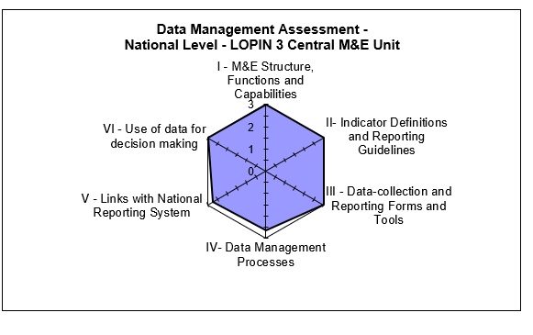

#### STRENGTHS – LOPIN 3 CENTRAL M&E UNIT

* Availability of trained M&E staff.
* Availability of the LOPIN 3 M&E data management SOP.
* Use of a CMP to guide changes to data.
* Data are being analyzed and used for decision making.

#### AREAS FOR IMPROVEMENT – LOPIN 3 CENTRAL M&E UNIT

* Guidelines are not in place to inform late receipt of reported data from lower reporting levels.

#### RECOMMENDATIONS – LOPIN 3 CENTRAL M&E UNIT

* Update the existing M&E guidelines to include a section that informs late receipt of data from lower reporting levels.

### LOPIN 3 STATE-LEVEL M&E UNIT

#### M&E STRUCTURE, FUNCTIONS, AND CAPABILITIES

The LOPIN 3 state level M&E unit is operated by the M&E Officer who performs the following functions:

* Conducts supervisory visits;
* Aggregates state-level data;
* Conducts monthly data quality checks on reported data; and
* Provides feedback to CBOs on reported data.

All state-level M&E Officers reported to have received relevant training to carry out their assigned responsibilities. Ebonyi state reported that the most recent training was conducted in January 2018 while Cross River state reported March 2018. The training was on the USAID/Nigeria OVC custom indicators as evidenced by M&E training manuals sighted at the Cross-River state LOPIN 3 office. The central level provides feedback on reported data and conducts supervisory visits to the state level on a quarterly basis. There were no major differences in the M&E structure, functions, and capabilities of the three states assessed.

#### INDICATOR DEFINITION AND REPORTING GUIDELINES

The two LOPIN 3 state offices make use of the PEPFAR MER indicator guide that defines the indicator and its method of calculation. In addition, M&E activities are guided by the LOPIN 3 M&E guidelines which include details on the reporting requirements and timelines.

#### DATA COLLECTION AND REPORTING FORMS AND TOOLS

The state M&E units aggregate data from NOMIS export files received from CBOs. The state offices also ensure the availability and consistent use of the national OVC tools by the CBOs. As of the time of the DQA exercise, there was no stock out of reporting tools at the state offices. Instructions were provided to the state offices on utilization of the tools through the guidance available in the indicator reference sheets.

#### DATA MANAGEMENT PROCESSES

At the two state offices, data verification checks are conducted on CBO data by the M&E Officer before submission to the central M&E unit. The DQA team observed that CBOs in Ebonyi state are not adhering to the reporting timeline. At both state offices, there were no written guidelines on late submission of reports. Both states have the LOPIN 3 M&E data management SOPs and the CMP form, which is completed and sent to the central office whenever there is a need to make changes to already reported data. Staff within both state offices conduct supervisory visits to the lower reporting levels regularly - monthly in Ebonyi state and quarterly in Cross River state. The DQA team also noted that the last documentation of supervisory visits in Ebonyi state was in February 2018.

Electronic data are backed up quarterly at the Ebonyi State office using an external hard drive while data backup is carried out at the Cross-River state office using both hard drive and cloud technology (SharePoint, Google drive and Dropbox). The state M&E units are aware that the data management SOP/M&E guidelines contain the storage period required for source documents (five years) and are aware of written documentation on how activity source documents should be archived.

#### LINKS WITH THE NATIONAL REPORTING SYSTEM

Indicator data generated at the two state offices have links with the National reporting system through data reported to both state Ministries of Women’s Affairs and Social Development (MWASD). Data are also reported by both state offices to the LOPIN 3 central M&E unit.

#### USE OF DATA FOR DECISION MAKING

The capacity of state M&E staff have been built to analyze data using Geographical Information System (GIS) maps and charts and to disseminate same to various stakeholders for decision making, including the Ebonyi State Agency for the Control of AIDS (SACA) and the State MWASD.

Figure 3 and Figure 4 show the spider graphs that display the M&E systems assessment for Cross River and Ebonyi states respectively. It can be observed that the data management system at the Ebonyi state office needs to be improved upon especially as regards ensuring that the CBOs adhere to reporting timelines and the consistent documentation of supervisory visits to lower reporting levels. Both states have gaps on links with the national reporting system as a result of the parallel reporting channels i.e., to government and donor agencies. However, there are mechanisms in place to harmonize reported data to both reporting entities such as data harmonization meetings.

*Figure 3. Spider Graph of M&E Systems Assessment: LOPIN 3 Cross River State*

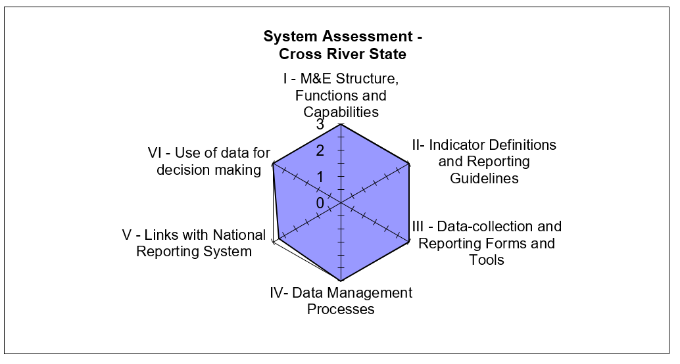

Figure 4:Spider Graph of M&E Systems Assessment: LOPIN 3 Ebonyi State

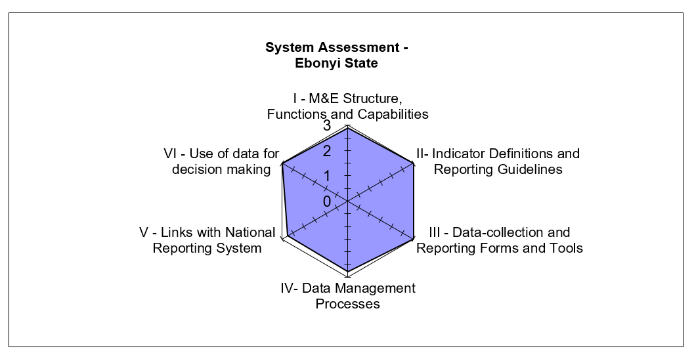

#### STRENGTHS - LOPIN 3 STATE LEVEL

* All state level M&E Officers have received relevant training to carry out their assigned responsibilities.
* Availability of the LOPIN 3 M&E data management SOP.
* Availability of the PIRS for the indicator being assessed.
* The NOMIS database is being used for reporting.
* Multiple data backup processes are in use e.g., hard drive and cloud.
* Data are collated, analyzed and presented in charts, tables, etc. to various stakeholders for decision making.

#### AREAS FOR IMPROVEMENT - LOPIN 3 STATE LEVEL

* Timeline for reporting are not adhered to by CBOs in Ebonyi state.
* Guidelines are not in place to inform late receipt of reported data from lower reporting levels.
* Inconsistency in documenting supervisory visits to lower reporting levels in Ebonyi state.

#### RECOMMENDATIONS - LOPIN 3 STATE LEVEL

* Ensure compliance of CBOs in Ebonyi state to reporting deadlines.
* Provide technical assistance to CBOs prior to reporting deadline to identify and resolve issues resulting in late submission of reports.
* Obtain and implement LOPIN 3 guidelines on late reporting of data from lower reporting levels.
* Update records of supervisory visits conducted by M&E unit staff of the LOPIN 3 Ebonyi state office.

### LOPIN 3 SERVICE DELIVERY LEVEL (CBOs)

A comparative M&E systems assessment for the six CBOs visited by the DQA team is presented below in narrative and tabular form, with details of the specific functional areas.

#### M&E STRUCTURE, FUNCTIONS, AND CAPABILITIES

All relevant staff of the CBOs within the two states have received M&E training however, most of the trainings were not within the period under review. Most of the CBOs mentioned that the trainings they have received were in 2015, 2016 and April – August 2017. One CBO in Ebonyi, DDNI reported a training received on the new PEPFAR OVC indicators in January 2018 while another CBO in Cross River, NCF reported a training received on M&E and CMP in 2018.

Community Volunteers (CVs) document beneficiary information on the OVC service forms and submit same to the CBO state offices. The Data Entry Clerks (DECs) collate the service forms and enter the information within the forms into the NOMIS. The CBO staff responsible for conducting data quality checks on data entered into the NOMIS varies from one CBO to the other. At most of the CBOs, the M&E Officer reviews the data before submission is made to the next level. However, in some organizations, the CBO Program Officer or Program Manager reviews reports before submissions are made.

Whenever the M&E Officer is unavailable, a staff of the CBO, trained in M&E acts as a suitable backstop. CBOs receive regular feedback from the state office on reported data during monthly M&E supervision visits, monthly data review meetings and via e-mails and phone calls. Three CBOs reported that they receive monthly supervision visits from the state level while the other three stated that they receive quarterly visits from the IP state offices. At NCF, the report of the last supportive supervision visit from the state level was not sighted by the DQA team.

#### INDICATOR DEFINITION AND REPORTING GUIDELINES

The PEPFAR PIRS for the indicator, provided by the LOPIN 3 central M&E unit, was available at the CBOs visited. CBOs also had the M&E Data Management SOP, which includes reporting requirements and deadlines for the submission of reports. At WCHDI, the DQA team sighted an outdated edition (2016 edition) of the “M&E guideline for OVC response in Nigeria,” which does contain the revised definition and calculations for the PEPFAR OVC indicators.

#### DATA COLLECTION AND REPORTING FORMS AND TOOLS

At all the CBOs, the data collection tools and forms which include household vulnerability assessment form, enrollment form, VC service form, risk assessment form, referral form, request and result form and HIV test result form, were available. Clear instructions on usage are contained in the LOPIN 3 M&E Data Management SOP. National paper-based tools and the NOMIS database were consistently utilized during the period under review. All CBOs had an adequate supply of data collection tools. At DDNI, it was stated that at community level, the CVs first record data in their notebooks before transferring into the service forms, which increases the likelihood for transcription errors.

#### DATA MANAGEMENT PROCESSES

Diverse methods are employed to ensure data quality and prevent double counting at the CBOs. In this regard, the findings at the CBOs visited include:

1. Utilization of a built-in NOMIS function that identifies and removes duplicate values (100 percent of CBOs);
2. M&E staff review data and conduct spots checks (100 percent of CBOs);
3. Compliance to the CMP when changes need to be made to reported data (RC, OIF and CACA); and
4. Use of a data validation template to conduct cross checks– an excel sheet that helps to detect data errors (DDNI).

CBOs back up data periodically using both cloud technology and an external hard drive. Complete details of the backup methods used by CBOs in Ebonyi and Cross River states are provided in the Annex, sections 8.5 and 8.6, Table 13 and Table 14.

In terms of confidentiality of beneficiary data, household folders are stored in locked cabinets, in rooms also under lock and key. At three of the CBOs, guideline on confidentiality of beneficiary data was sighted. At all the CBOs, its required that a confidentiality form is filled and signed by non-CBO staff before they gain access to any beneficiary data. The NOMIS database at the CBOs is passworded, with limited access to only authorized staff. Good filing system was observed at four of the CBOs (RC, WCHDI, DDNI and OIF). At CACA and NCF, folders of active beneficiary households were not separated from folders of graduated households. Beneficiary folders were arranged horizontally in the storage cabinets while service forms were not arranged orderly within the folders, making retrieval difficult. Staff at all the CBOs were aware that the LOPIN 3 M&E data management SOP contains the storage period required for source documents (5 years).

#### LINKS WITH NATIONAL REPORTING SYSTEM

Indicator data generated at the CBOs have links with the National reporting system through data reported to respective LGA OVC focal persons, who in turn report to the State MWASD. Data are also reported by the CBOs within both states to respective LOPIN 3 state offices.

The NOMIS system clearly records information about where the services are rendered, using standardized naming conventions (e.g., the state, LGA and ward) and unique identification codes.

#### USE OF DATA FOR DECISION MAKING

All the CBOs reported that the M&E Officer analyzes data to develop charts, tables etc. for dissemination to various stakeholders including the Local Agency for the Control of AIDS (LACA) and State MWASD. CBO staff are provided with technical guidance on data use during data review meetings, performance review meetings and supervisory visits. Analyzed data informed interventions that led to an increase in child enrollment into the OVC program at RC CBO. Limitations in data were not included when data was disseminated by RC, WCHDI, CACA and DDNI CBOs.

#### STRENGTHS – LOPIN 3 CBO LEVEL

* CBOs have trained M&E staff.
* Suitable backstop is available to fill-in for the M&E officer when unavailable.
* The PIRS on the indicator, SOP for data management and national OVC tools are available and in-use.
* NOMIS software in use and password protected.
* Beneficiaries folders are stored under lock and key with limited access.
* Data are backed up routinely using external drive and the cloud.
* Data are analyzed and used for decision making.
* Good filing and storage system of beneficiary records.
* CMP is used when changes are made to reported data.
* Written policy available on the storage period for source documents.

#### AREAS FOR IMPROVEMENT – LOPIN 3 CBO LEVEL

* Use of notebooks by CVs to record beneficiary information before transferring to the service forms at DDNI.
* Limitations in data are not included when data are being disseminated by RC, WCHDI, CACA and DDNI.
* At CACA and NCF, folders of active beneficiary households were not separated from folders of graduated households. Beneficiary folders were arranged horizontally in the storage cabinets while service forms were not arranged orderly within the folders, making retrieval difficult.

#### RECOMMENDATIONS – LOPIN 3 CBO LEVEL

* Build the capacity of CBO M&E staff to include limitations in data when disseminating to stakeholders and to file same for reference purpose.
* Build the capacity of CBO staff to properly store beneficiary folders by separating active beneficiary households from graduated household folders; arrange folders vertically within the storage cabinets; and arrange service forms orderly within the folders for easy retrieval.
* Conduct re-fresher training for CVs on completion of data collection tools and discourage the use of notebooks (DDNI).

## DATA QUALITY STANDARDS

### VALIDITY

Validity is the extent to which a measurement is well-founded and corresponds accurately to the real world. It pertains to measuring what is intended to be measured. Details of the DQA team’s review of data quality in the context of the OVC indicator are provided below.

#### DATA COLLECTION

The data, including HIV status are collected at the point of registration into the OVC program, during provision of service and follow up visits using the “Vulnerable Children Enrollment Form,” “Vulnerable Children Service Form,” and “Vulnerable children follow up Child Status Index (CSI) form.” In addition, other tools for HIV test results, HIV risk assessment results and other confidential and case management and monitoring tools are used to document the HIV status of beneficiaries.

#### DOES THE DATA COLLECTED MEASURE WHAT IT IS SUPPOSED TO MEASURE?

As part of the OVC_HIVSTAT indicator, data collected include ‘total number of OVC less than 18 years with HIV status reported to IPs (including report of no status).’ The OVC_HIVSTAT indicator for LOPIN 3 matches the PIRS and is a direct measurement by definition. The data collected in the project measures total number of OVC less than 18 years who reported their HIV status including report of no status to LOPIN 3.

#### UNDERSTANDING THE INDICATOR DEFINITION

The PIRSs for the indicator is available at all the levels assessed. Staff are conversant with it at the state and CBO levels.

#### DATA REPORTING

At the central level, 100 percent of the OVC_HIVSTAT data reported by the two states to the central level were available for assessment, and matched the data submitted to the USAID. However, only two out of its three disaggregates: ‘Reported HIV negative to the IP’ and ‘No HIV status reported to the IP’ had a 100 percent match with reported data, with the ‘Reported HIV positive to the IP’ disaggregate having a 94 percent match/VF (Figure 5).

At the state level, the re-aggregated total OVC_HIVSTAT data and its disaggregates were also a 100 percent match with the reported data, except for the ‘Reported HIV positive to the IP’ disaggregate in Cross River (VF of 91 percent) – Table 12, Annex Section.

Figure . Verification Factor: LOPIN 3 Central Level OVC_HIVSTAT Numerator Total and Disaggregates

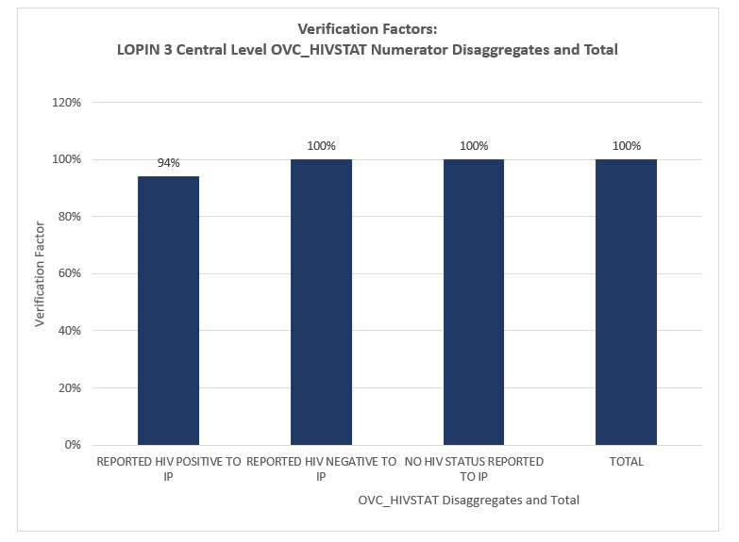

At the CBO level, the two CBOs visited in Ebonyi state had verification factors of 100 percent across the total OVC_HIVSTAT data and its disaggregates. In Cross River State, two of the four CBOs over-reported on the total OVC_HIVSTAT data, NCF had a VF of 44 percent and RC had a VF of 94 percent. The remaining two CBOs in Cross River under-reported on the total OVC_HIVSTAT data, OIF had a VF of 111 percent and CACA had a VF of 105 percent (Figure 6). The OVC_HIVSTAT disaggregate data for the four CBOs visited in Cross River were similarly over-reported and under-reported, with only NCF’s ‘Reported HIV positive to the IP’ disaggregate figure (VF of 100 percent) being the exception (Annex Section Table 12). The reasons stated for the large variances in the verification factors include:

* An error of summated data in the totals row of the customised LOPIN 3 CSO Vulnerable Household/Children MSF used by the CBOs during data collation;
* Data entry and data collation errors at the CBOs; and
* The loss of data following NOMIS data export (at NCF).

Figure . Verification Factors for LOPIN 3 Ebonyi and Cross River States and CBOs, OVC_HIVSTAT Numerator Totals

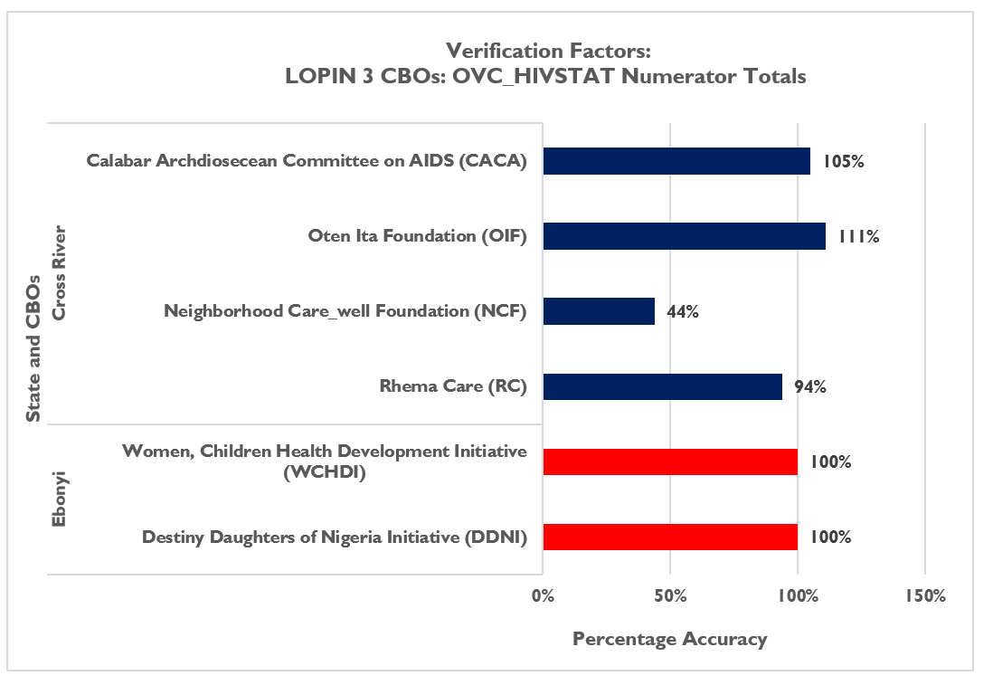

With consideration of the +/- ten percent acceptable variance for determining the accuracy of verified data, both states had verification factors within the acceptable range for data validity (VF of 100 percent for both states). Four CBOs, DDNI & WOCHAI in Ebonyi state and RC & CACA in Cross River state had data verification factors within the acceptable range for data validity (Figure 6). Overall average accuracy of verified data across all sites visited (central, state and CBOs) was 97 percent (Figure 7), therefore, data reported are considered suitable for decision making.

*Figure 7: Average Data Verification Factors by Level of Reporting System for LOPIN 3*

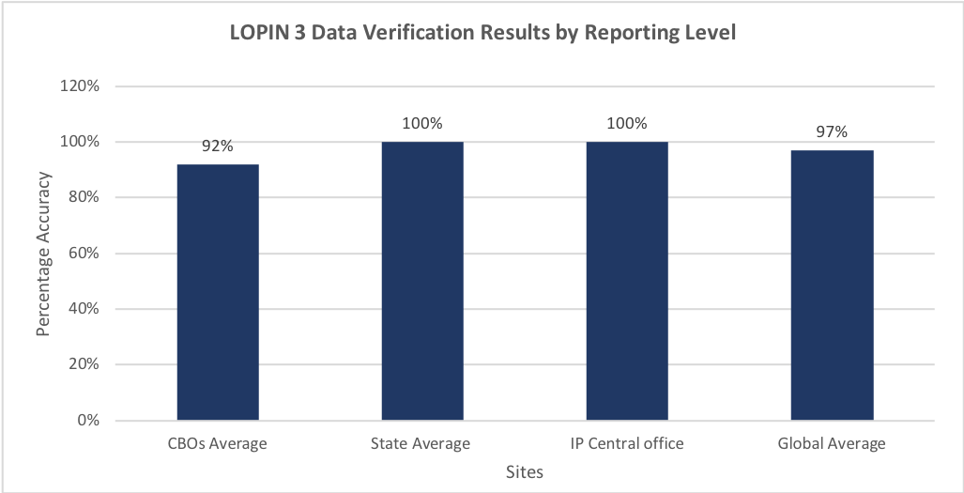

#### STRENGTHS

* Data for the OVC_HIVSTAT indicator is collected as stipulated by the indicator reference guide using national approved tools.
* The “HIV status update form” on the NOMIS is used to input and update the HIV status of the beneficiaries for accurate reporting.

#### VALIDITY ISSUES IDENTIFIED

Validity Issue 1:Transcription/data entry errors due to incomplete entries in the source documents and in the NOMIS (Table 5).

Errors from documenting incorrect entries in the service forms were observed at the four CBOs visited in Cross River state. Six percent of beneficiary forms reviewed during the cross checks had incomplete, missing or incorrect entries. During the cross-checks from the NOMIS to the source documents, data entry errors were identified at the same four CBOs in Cross River state. Thirty-one percent of NOMIS entries reviewed showed data entry errors during data transfer from the source documents to the NOMIS. At OIF, RC, NCF and CACA, the HIV status of beneficiaries were updated on the service forms but not on the NOMIS.

Table 5: Cross-Check Findings from LOPIN 3 CBOs in Ebonyi and Cross River States

|  |  |  |  |  |  |  |  |  |
| --- | --- | --- | --- | --- | --- | --- | --- | --- |
| Cross Check Findings for LOPIN 3 Sites | | | | | | | | |
| Cross Check Findings | **Ebonyi** | | **Cross River** | | | | **Total** | |
| WCHDI | DDIN | NCF | RC | OIF | CACA | No. | % |
| Total cross checks: NOMIS to beneficiary folders and vice versa | 20 | 20 | 20 | 20 | 20 | 20 | 120 |  |
| Total cross checks by beneficiary forms | 280 | 240 | 100 | 120 | 100 | 100 | 940 |  |
| Number of beneficiary forms within complete, missing or incorrect entries | 0 | 0 | 2 | 32 | 9 | 15 | 58 | 6% |
| Number of NOMIS entries that are incomplete, missing or incorrect | 0 | 0 | 4 | 24 | 4 | 5 | 37 | 31% |

Validity Issue 2**:** Errors identified during data verification

The DQA team noted errors during the data verification as detailed in the data reporting section above 4.2.1.4. Findings from recounted data aggregated at the CBOs varied from state to state as shown graphically in Figure 6 above. The verification factor, calculated based on findings at the four CBOs visited in Cross River state revealed over-reported and under-reported data. The data verified and verification factors for the data at the LOPIN 3 central, state and CBO levels are in Table 11and Table 12 in the Annex section.

#### RECOMMENDATIONS FOR IMPROVING DATA VALIDITY

* Improve supervisory efforts with the CBOs to ensure the completeness and accuracy of data entry, data collation and the proper use of the NOMIS.
* Provide refresher training on the NOMIS software to DECs.
* Provide support to CBO M&E officers to conduct periodic folder audits to resolve discrepancies observed during cross checks.
* Update NOMIS software to the most recent version to address NOMIS data discrepancies.
* Amend the error of summated data in the totals row of the customised LOPIN 3 CSO Vulnerable Household/Children MSF.

### RELIABILITY

#### MECHANISMS TO ENSURE DATA RELIABILITY

The LOPIN 3 IM utilized the National OVC reporting tools consistently during the report period. At one CBO (DDNI), it was observed that notebooks were being used by CVs to document data before transferring to the service forms. Data are retrieved on the indicator from the NOMIS and reported only as the number of OVC less than 18 years with HIV status reported to the IP. All LOPIN 3 CBO and state-level reports for the period under assessment were available for review and complete along the same reporting format.

At the state level, the NOMIS aggregation and reporting platform was consistently used. Data exported from the NOMIS were aggregated and exported to the LOPIN 3 central office, were it was extracted and reported to USAID using the Data for Accountability Transparency Impact Monitoring (DATIM) reporting platform. This ensured consistency and reliability in the data collection processes across all reporting levels.

#### STRENGTHS

* The use of National OVC reporting tools.

#### AREAS FOR IMPROVEMENT

* The use of notebooks by DDNI CVs to document data before transferring to the service forms.

#### RECOMMENDATION

* Conduct re-fresher training for CVs on completion of data collection tools and discourage the use of notebooks for data collection (DDNI).

### PRECISION

#### MECHANISMS TO ENSURE DATA PRECISION

The data collected in the enrollment, service and follow-up forms are entered in the NOMIS in a consistent manner, and detailed level of information on the HIV status of the OVC less than 18 years are reported. The nationally approved data fields in the forms are entered into the NOMIS. Since the NOMIS has household-level and individual-level data, it has sufficient detail and precision to provide information on HIV status of OVC less than 18 years, while ensuring that beneficiary confidentiality is protected. Data elements on the three forms have information fields such as date, sex, age, child HIV status, and services provided, which also have corresponding fields in the NOMIS. In addition, the NOMIS has a data entry page that enables update of the HIV status of beneficiaries. The level of precision in the data collection forms and the NOMIS matches the requirements in the PIRS.

#### AREAS FOR IMPROVEMENT

* None

#### RECOMMENDATION

* None

### TIMELINESS

#### MECHANISMS TO ENSURE TIMELINESS

The DQA team noted a non-compliance to reporting deadlines by the CBOs and state IP offices. In Cross River state, this was attributed to increased workload on CBO staff. The central M&E unit has no written procedure to address late reporting of data from lower levels. Figure 8 shows the reporting performance at the LOPIN 3 reporting levels.

Figure 8. Reporting Performance – Results by State and Aggregate of States Results

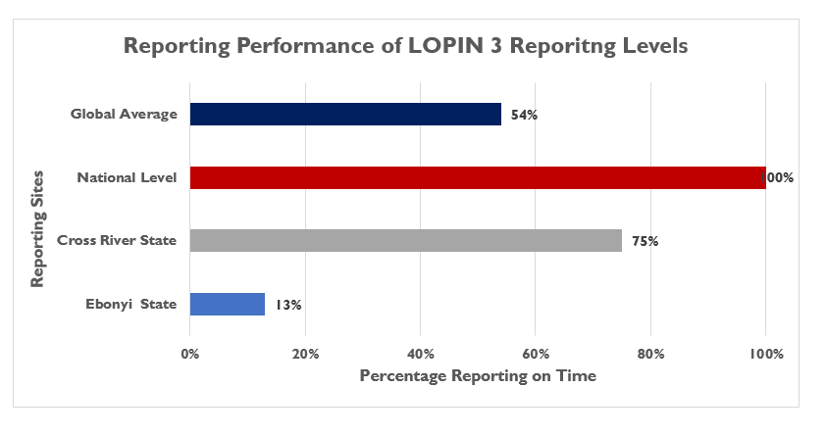

#### AREAS FOR IMPROVEMENT

* Late submission of reports from states and CBOs.
* No written guidelines on how to address late reporting at central level.

#### RECOMMENDATION

* Develop written guidelines to address late reporting.
* Ensure timely reporting by the state offices by sending reminder e-mails a few days before the deadline for reporting.
* Review the work load of the CVs and DECs and make provision for support staff if necessary.

### INTEGRITY

#### MECHANISMS TO ENSURE INTEGRITY OF DATA

LOPIN 3 data collection and management process at the central IP level is through the NOMIS. Data validation processes executed by the M&E team ensures that the data collated by LOPIN 3 undergoes data quality checks.

At the state level, the LOPIN 3 M&E Officers conduct data quality checks on data in the NOMIS platform. The password-protected NOMIS at the state level ensures confidentiality. Table 6 and Table 7 below present the mechanisms in use by LOPIN 3 to ensure data integrity.

Table 6. Mechanisms for Ensuring Data Integrity Across LOPIN 3 Reporting Levels

|  |  |  |
| --- | --- | --- |
| CENTRAL | STATE LEVEL | CBO LEVEL |
| * Built-in checks in NOMIS that remove double entries * Supervisory visits * Quarterly review meetings | * Dedicated staff conducting quality checks * Built-in checks in NOMIS that remove double entries * Data review meetings * Utilization of the LOPIN 3 CMP * Supervisory visits to CBOs * Follow-up emails and phone calls to CBOs | * The use of the password-protected NOMIS (100%) * Built-in checks in NOMIS that remove double entries (100%) * Dedicated staff to check for data quality (100%) * Limited access to the filing cabinet where source documents are kept (100%) * Utilization of the LOPIN3 CMP for data updates to ensure data accuracy (RC, OIF and CACA) * Conduct of post-data entry data verifications (DDNI) * Use of an excel data validation template to check for data entry errors (DDNI) |

Table 7. Mechanisms for Ensuring Data Integrity Across LOPIN 3 States

|  |  |  |
| --- | --- | --- |
| Data Management Process | Ebonyi | Cross River |
| Quality control to avoid double counting | Relies on built-in cross-checks in NOMIS | Relies on built-in cross-checks in NOMIS |
| Confidentiality | Password on NOMIS with limited access | Password on NOMIS with limited access |
| Backup procedure | Hard Drive | External Drive, Cloud |
| Providing feedback | Review Meeting  Supervisory meetings | Review Meetings  Supervisory visits  E-mails  Phone calls  Verbal feedback |

#### STRENGTHS

All the mechanisms outlined above are strengths in the M&E system of LOPIN 3, to ensure data integrity of indicator data.

#### AREAS FOR IMPROVEMENT

* None.

#### RECOMMENDATION

* None.

# Action plan for LOPIN 3

A suggested action plan for the various levels is outlined below (Central Level Action Plan –Table 8; State-Level Action Plan –Table 9; and CBO-Level Action Plan –Table 10).

## ACTION PLAN FOR LOPIN 3 CENTRAL LEVEL

Table 8. Action Plan for LOPIN 3 Central Level

|  |  |  |  |
| --- | --- | --- | --- |
| Areas for Improvement | Description of Action Point | Responsible | Timeline |
| No guideline to inform late receipt of reported data from lower reporting levels. | Update M&E guideline to include section on steps to be taken to address late receipt of reported data from lower reporting levels. | HIFASS M&E Director | September 2018 |
| Incorrect calculation of totals on the customized LOPIN 3 CSO Vulnerable Household/Children MSF. | Amend the error of summated data in the totals row of the customized LOPIN 3 CSO Vulnerable Household/Children MSF. | HIFASS M&E Director | September 2018 |

## ACTION PLAN FOR LOPIN 3 STATE LEVEL

Table 9. Action Plan for LOPIN 3 State Level

|  |  |  |  |
| --- | --- | --- | --- |
| Areas for Improvement | Description of Action Point | Responsible | Timeline |
| Errors observed in reported data during data verification. | * Improve supervisory efforts with the CBOs to ensure accurate data entry and proper use of the NOMIS. * Conduct refresher training for DECs on the NOMIS software. * Ensure all CBOs conduct data quality cross checks between NOMIS soft copy data and a hard copy Excel NOMIS data before reporting. * Provide support to CBO M&E officers to conduct periodic folder audits to resolve discrepancies observed during cross checks. | HIFASS State M&E Officers | September 2018 |
| CBOs not adhering to reporting timeline. | * Ensure compliance of CBOs in Ebonyi state to reporting deadlines. * Provide technical assistance to CBOs prior to reporting deadline to identify and resolve issues resulting in late submission of reports. * Obtain and implement LOPIN 3 guidelines on late reporting of data from lower reporting levels. * Review the work load of the CVs and data entry clerks and make necessary recommendations to ease the work load in the CBOs. | HIFASS State M&E Officers | September 2018 |
| Non-documentation of supervisory visits conducted by Ebonyi state office staff. | * Update records of supervisory visits conducted by staff of the Ebonyi state office. | HIFASS Ebonyi State M&E Officer | September 2018 |
| Limitations in data are not included when data are being disseminated by RC, WCHDI, CACA and DDNI CBOs. | * Build the capacity of CBO M&E staff to include limitations in data disseminated to stakeholders and to file same for reference purpose. | HIFASS State M&E Officers | September 2018 |
| Folders of active beneficiary households were not separated from folders of graduated households (CACA and NCF).  Beneficiary folders were arranged horizontally in the storage cabinets while service forms were not arranged orderly within the folders, making retrieval difficult. | Build the capacity of CBO staff to:   * Properly store beneficiary folders by separating active beneficiary households from graduated household folders; * Arrange folders vertically within the storage cabinets; and * Arrange service forms orderly within the folders for easy retrieval. | HIFASS State M&E Officers | September 2018 |

## ACTION PLAN FOR LOPIN 3 CBO LEVEL

Table 10. Action Plan for LOPIN 3 CBO Level

|  |  |  |  |
| --- | --- | --- | --- |
| Areas for Improvement | Description of Action Point | Responsible | Timeline |
| Use of notebooks by DDNI CBO CVs to document beneficiary’s information before transferring it to the service forms. | Conduct re-fresher training for CVs on completion of data collection tools and discourage the use of notebooks (DDNI). | DDNI M&E Officer | September 2018 |
| Loss of data during NOMIS Export | Update NOMIS software to the most recent version to address NOMIS data discrepancies | CBO M&E Officers | Immediately |

# Limitations and Constraints

1. DQAs at a country level are complex exercises and require significant resources and effort on the part of the commissioning agency, the agency conducting the DQA, IPs, and government functionaries in the relevant sectors. As mentioned in USAID’s “How-To Note: Conduct a DQA,”[5] notification of an impending DQA can also cause stress for the IP, given the ramifications of activity performance and the potential uncertainty of USAID’s expectations. Although the MEL Activity DQA team tried to allay initial apprehensions of the IP and its staff about the outcomes from the DQA, there may have been residual concerns that could not be fully addressed. The DQA team emphasized to the IP that subsequent to completion and dissemination of the final report, the DQA results are intended to be a tool for USAID and the IP to work together, to resolve any data quality issues or limitations discovered during the exercise.
2. The sampling of the two LOPIN 3 states (Ebonyi and Cross River), as well as the CBO sites visited in the states, was based on a purposive methodology, with consideration to security and feasibility issues, and was also guided by USAID. The ideal sampling methodology would have been to use a statistically valid scientific method, as described in the MEASURE Evaluation DQA guidelines[6]. Implementation of a statistically valid method was constrained by security and other eligibility considerations outlined in section 3.3. This was partially compensated for by the number of CBOs covered during the DQA.
3. To ensure adequate time for the DQA teams in the field to complete all aspects of the DQA, including the M&E systems assessment, review of the data quality standards, data verifications, and cross-checks, a limited number of cross-checks could be performed at each CBO (service delivery level). At most CBOs, at least twenty beneficiary folders were reviewed during the cross-checks. As described in detail in section 3.4.4, this limitation was partially addressed by using random selection of beneficiary folders (where feasible) from all household folders for the two reported quarters. Also, cross-checks were attempted in two directions—i.e., ten records were traced from the beneficiary forms/household folders to the NOMIS, and an additional ten unique beneficiary records were traced from the NOMIS back to the beneficiary folders for cross-verification.

# Conclusions

From the USAID/Nigeria and PEPFAR perspective, the DQA for OVC indicators serves to meet the operational policy requirements of USAID/Washington and USAID/Nigeria. It also serves to review the M&E system, identify best practices, and develop recommendations to improve existing systems, for better reporting of program indicators in subsequent funding cycles.

The LOPIN 3 IM has implemented some of the recommendations from the FY 2017 DQA on the OVC_SERV indicator, which has improved its M&E system e.g., updating the data management guidelines with a section addressing data change management procedures. However, some of the areas noted for improvement during the FY 2017 DQA were still found to be a challenge during this FY 2018 DQA exercise e.g., data verification errors observed at the service delivery level.

The M&E system’s areas of strength across the three levels assessed include the availability of trained M&E staff with clearly assigned responsibilities, availability of a data management SOP that guides M&E processes and the availability and use of the PEPFAR indicator reference guide. The areas for improvement across the levels assessed include the need to ensure compliance to reporting timelines at lower reporting levels, ensure documentation of supervisory visits and provide capacity building to CBOs to improve the filing system of beneficiary folders.

With reference to the ADS 201 definition of data quality standards (Table 1), OVC_HIVSTAT indicator data reported by LOPIN 3 can be judged valid. With consideration to the +/- ten percent acceptable variance for determining the accuracy of verified data, overall average accuracy of verified data across all sites visited (central, state and CBOs) was 97 percent (Figure 7), therefore, data reported are considered suitable for decision making. Data was also found to be reliable, precise and have integrity. The validity of the LOPIN 3 indicator data can be strengthened by improving supervisory efforts at the state offices and CBOs. Timeliness of reported can be improved by providing technical assistance to CBOs prior to reporting deadline to identify and resolve issues resulting in late submission of reports.

USAID/Nigeria is recommended to establish a community of practice of NOMIS users to facilitate the identification of effective approaches to resolving the NOMIS software issues and data loss in NOMIS following data export and NOMIS software upgrade.

# Annexes

## LIST OF SITES VISITED AND LOCATIONS: LOPIN 3 DQA

A complete list of sites and locations visited is provided on Table 3 in section 3.2 of this report.

## STEPS FOR DATA VERIFICATION USING THE MEASURE EVALUATION TOOL

*Figure 9. Tracing and Verifying Reported Totals: CBO via State to Central M&E Unit*

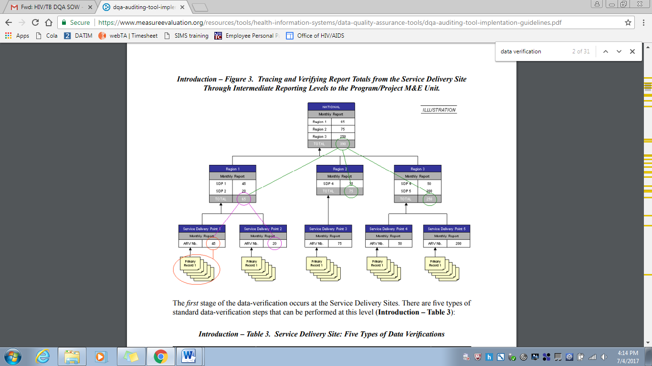

Source: MEASURE Evaluation (2008).

## OVC VERIFICATION FACTORS – LOPIN 3 CENTRAL, STATE AND CBO LEVELs

Table 11. OVC_HIVSTAT Disaggregates for the Central, State and CBO Levels

|  |  |  |  |  |  |  |  |  |  |
| --- | --- | --- | --- | --- | --- | --- | --- | --- | --- |
|  |  | VERIFIED DATA | | | | REPORTED DATA | | | |
| SITE NAME | **STATE/LGA** | **A: Reported HIV positive to IP** | **B: Reported HIV negative to IP** | **C: No HIV status reported to the IP** | **Total: A+B+C** | **A: Reported HIV positive to IP** | **B: Reported HIV negative to IP** | **C: No HIV status reported to the IP** | **Total: A+B+C** |
| HIFASS LOPIN 3 HQ Office |  | 192 | 24,713 | 16,886 | 41,791 | 204 | 24,701 | 16,886 | 41,791 |
| Ebonyi IP State Office |  | 72 | 7,969 | 4,569 | 12,610 | 72 | 7,969 | 4,569 | 12,610 |
| Cross River IP State Office |  | 120 | 16,744 | 12,317 | 29,181 | 132 | 16,732 | 12,317 | 29,181 |
| Destiny Daughters of Nigeria Initiative | Ebonyi/Ivo | 8 | 864 | 70 | 942 | 8 | 864 | 70 | 942 |
| Women, Children Health Development Initiative | Ebonyi/Afikpo South | 1 | 630 | 1,179 | 1,810 | 1 | 630 | 1,179 | 1,810 |
| Neighborhood Care-well Foundation | Cross River/Calabar South | 14 | 1,065 | 562 | 1,641 | 14 | 3,378 | 355 | 3,747 |
| Rhema Care | Cross River/Calabar South | 35 | 1,714 | 756 | 2,505 | 18 | 2,413 | 229 | 2,660 |
| Oten Ita Foundation | Cross River/Calabar Municipal | 30 | 2,543 | 2,109 | 4,682 | 36 | 4,083 | 109 | 4,228 |
| Calabar Archdiosecean Committee on AIDS | Cross River/Akampa | 15 | 3,252 | 1,042 | 4,309 | 4 | 1,748 | 2,349 | 4,101 |

Table 12. Verification Factors – OVC_HIVSTAT Disaggregates for the Central, State and CBO Levels for LOPIN 3

|  |  |  |  |  |  |
| --- | --- | --- | --- | --- | --- |
|  |  | VERIFICATION FACTORS | | | |
| SITE NAME | **STATE/LGA** | **A: Reported HIV positive to IP** | **B: Reported HIV negative to IP** | **C: No HIV status reported to the IP** | **Total: A+B+C** |
| HIFASS LOPIN 3 HQ Office |  | 94% | 100% | 100% | 100% |
| Ebonyi IP State Office |  | 100% | 100% | 100% | 100% |
| Cross River IP State Office |  | 91% | 100% | 100% | 100% |
| Destiny Daughters of Nigeria Initiative | Ebonyi/Ivo | 100% | 100% | 100% | 100% |
| Women, Children Health Development Initiative | Ebonyi/Afikpo South | 100% | 100% | 100% | 100% |
| Neighborhood Care-well Foundation | Cross River/Calabar South | 100% | 32% | 158% | 44% |
| Rhema Care | Cross River/Calabar South | 194% | 71% | 330% | 94% |
| Oten Ita Foundation | Cross River/Calabar Municipal | 83% | 62% | 1935% | 111% |
| Calabar Archdiocesan Committee on AIDS | Cross River/Akampa | 375% | 186% | 44% | 105% |

## 

## DIAGRAMMATIC REPRESENTATION OF CROSS-CHECKS AT CBO LEVEL

*Figure 10.* *Methodology for Cross-Checks at CBO Level*

**OVC CROSS CHECK AT CBO**

CROSS CHECK 1

CROSS CHECK 2

Select 10 Enrolment numbers and unique identifiers within the Reporting Period from NOMIS

Select 10 Beneficiary Service Forms (randomly where feasible) within the Reporting Period from 10 Folders (Using Enrolment Number and Unique Identifiers)

Confirm enrollees in NOMIS have 10 corresponding service forms

Confirm 10 enrollees are present on the NOMIS

Trace and Find Corresponding Entries and Compare in the NOMIS

Trace and Find Corresponding Entries and Compare in the Service Forms

## DATA BACKUP MECHANISMS IN EBONYI state CBOs

Table 13. Backup Mechanisms Utilized in Ebonyi State CBOs Visited

|  |  |  |  |  |  |  |  |  |  |  |  |
| --- | --- | --- | --- | --- | --- | --- | --- | --- | --- | --- | --- |
| Name of CBO | Backup Mechanism Utilized | | | | | | | |  |  | Timeline |
| Cloud Based | | | | Hard Drive | Flash Drive | Official Laptops | Personal devices | C. drive | E-Mail |  |
| Unspecified | OneDrive | Google Drive | Drop Box |  |  |  |  |  |  |  |
| WCHDI |  |  |  |  | √ |  |  |  |  |  | Weekly |
| DDNI | √ |  |  |  | √ |  |  |  |  |  | Bi Monthly |

## DATA BACKUP MECHANISMS IN CROSS RIVER STATE CBOs

Table 14. Backup Mechanisms Utilized in Cross River State CBOs Visited

|  |  |  |  |  |  |  |  |  |  |  |  |
| --- | --- | --- | --- | --- | --- | --- | --- | --- | --- | --- | --- |
| Name of CBO | Backup Mechanism Utilized | | | | | | | |  |  | Timeline |
| Cloud Based | | | | Hard Drive | Flash Drive | Official Laptops | Personal devices | E-mails | C Drive |  |
| Unspecified | One Drive | Google Drive | Drop Box |  |  |  |  |  |  |  |
| NCF |  |  |  | √ | √ |  |  |  |  | √ | Weekly  Monthly |
| OIF |  |  | √ | √ |  |  |  |  |  |  | Monthly |
| CACA |  |  | √ |  | √ |  |  |  |  |  | Weekly |
| RC |  |  | √ |  | √ |  |  |  |  |  | Monthly |

## PERFORMANCE INDICATOR REFERENCE SHEET (PIRS)

Table 15: Performance Indicator Reference Sheet for OVC_HIVSTAT

|  |  |  |  |  |
| --- | --- | --- | --- | --- |
| **OVC_HIVSTAT** | | | | |
| Description: | Percentage of orphans and vulnerable children (<18 years old) with HIV status reported to implementing partner (including report of no status). | | | |
| Numerator: | Number of orphans and vulnerable children (<18 years old) with HIV status reported to implementing partner, disaggregated by status type. | | Data sources for this indicator include HIV test results that are self-reported by OVC (or their caregivers), results of HIV Risk Assessments conducted by implementing partners, registers, referral forms, client records, or other confidential case management and program monitoring tools that track those in treatment and care. | |
| Denominator: | Number of orphans and vulnerable children reported under OVC_SERV (<18 years old) | | Denominator is not collected again, as part of this indicator but is collected under the indicator OVC_SERV. | |
| Changes in indicator: | • This indicator formerly called OVC_ACC (MER 1.0) and OVC_KNOWNSTAT (in the original MER 2.0 target setting documentation guidance) was changed to OVC_HIVSTAT to reflect that HIV status is self- reported to the implementing partner by the OVC or OVC caregiver (MER 1.0 to MER 2.0). | | | |
| How to use: | |  | | --- | | This indicator will be tracked through routine program monitoring semi- annually through the POART process.  Given the elevated risk of HIV infection among children affected by and vulnerable to HIV, it is imperative for PEPFAR implementing partners to monitor HIV status among OVC beneficiaries, and to facilitate access and retention in ART treatment for those who are HIV positive. When the implementing partner knows the HIV status, the program can contribute to ensuring that the children are linked to appropriate care and treatment services, all essential elements of quality case management. OVC programs can also play an important role in family-centered disclosure, for those who are HIV positive.  • This indicator is NOT intended to be an indicator of HIV tests performed or receipt of testing results, as these are measured elsewhere and test results are frequently unavailable to community organizations due to health facility concerns about patient confidentiality.  • This indicator is NOT intended to imply that all OVC beneficiaries require an HIV test. OVC with known positive or negative status do not need to be tested. Only OVC with no HIV status or children reported to be negative and recently experiencing sexual violence and/or other risk factors in the reporting period should be assessed for HIV risk. For older children who the IP thinks may be sexually active, they should be assessed every reporting period.  • Status disclosure to the implementing partner is NOT a prerequisite for enrollment or continuation in an OVC program. OVC programs serve persons of positive, negative, and unknown HIV status appropriate to their needs and vulnerability to HIV. This indicator ensures that IPs are regularly providing outreach to caregivers to identify children’s HIV status, encourage family disclosure and linkage to care and treatment as needed.  • This indicator captures if implementing partners are tracking the self-reported HIV status of the orphans and vulnerable children they serve and enrollment in ART for those who are positive. Testing results for OVC who are referred for testing should be reported under HTS_TST based on the service delivery point where they were tested  This indicator also captures if implementing partners are tracking if the orphans and vulnerable children they serve who report to be HIV positive are successfully linked to and retained in treatment and care.  • This indicator is a subset from OVC_SERV. Only OVC who were reported under OVC_SERV <18 should be included in the denominator for this indicator.  • Since this is not a testing indicator, HIV positivity yield should NOT be calculated based on this indicator. Yield calculations should only be made by testing partners. | | | | |
| How to collect: | Data sources for this indicator include HIV test results that are self-reported by OVC (or their caregivers), results of HIV Risk Assessments conducted by implementing partners, registers, referral forms, client records, or other confidential case management and program monitoring tools that track those in treatment and care.  Implementation of the HIV risk assessment should be integrated into case management and on-going case monitoring and should not be conducted separately, if possible. This will vary by partner and project. The partners should work out a timeline based on their experience of how long referral completion and status disclosure usually takes and factor that into their case management processes.  Implementing partners will record the OVC beneficiary’s self-reported HIV status –semi-annually. | | | |
| Reporting level: | Facility & Community | | | |
| How often to report: | Semi-Annual | | | |
| How to review for data quality: | The OVC_HIVSTAT total numerator should ideally equal OVC_SERV<18 results. In some cases, there may be missing data for the following reasons: 1) IP was not able to collect this information from all caregivers of OVC_SERV<18 within the reporting period, 2) IP was not able to locate all the caregivers of OVC_SERV<18 (e.g., relocated, migrant work), 3) data entry error and/or 4) Peace Corps is currently not reporting on this indicator so OVC served <18 under PC would be missing.  Review any site with the following reporting issues: 1) numerator greater than 100% of OVC_SERV <age 18, 2) very low coverage of OVC_HIVSTAT, 3) sum of “Currently on ART” and “Not currently on ART” do no equal the “Reported HIV positive to IP” results and 5) sum of “Test not indicated” and “Other reasons” do not equal “Reported No Status to IP”. | | | |
| How to calculate annual total: | Use result reported at Q4. | | | |
| Data elements (components of indicator): | Numerator:  Number of orphans and vulnerable children (<18 years old) with HIV status reported to implementing partner, disaggregated by status type. | Disaggregate Groups | | Disaggregates |
| Status Type  [Required] | | • Reported HIV positive to implementing partner  o Currently receiving ART  o Not currently receiving ART  • Reported HIV negative to implementing partner  • No HIV status reported to the implementing partner  o Test not indicated based on HIV risk assessment  o Other reasons |
| Disaggregate Descriptions & Definitions | | | |
| Status Type Disaggregate Definitions:  “Reported HIV Positive to IP”: includes beneficiaries <age 18 who report to the IP that they are HIV positive based on an HIV test conducted during or prior to the reporting period (regardless of where the test occurred). All entries for “reported HIV positive to IP” should be further disaggregated as “currently receiving ART” or “not currently receiving ART.” This also includes beneficiaries <age 18 who report that they are HIV positive based on an HIV test conducted during previous project reporting periods. OVC entered as “Reported HIV positive to IP” in the previous reporting period, should continue to be reported as positive during the current reporting period and their enrollment in ART noted.  • “Reported HIV negative to IP” includes beneficiaries <age 18 who report that they are HIV negative to the IP based on an HIV test conducted during the reporting period (regardless of where the test occurred). For a child who reports multiple tests within the current period, use most recent test. For beneficiaries entered as “Reported HIV negative to IP” in a previous reporting period—if the IP believes the child’s risk has not changed in the last six months, they should continue to report the child as negative during the current reporting period. However, if the IP believes that the child has recently been exposed to risk of HIV infection (e.g., sexual violence) or if an adolescent has become sexually active, then the IP should conduct the HIV risk assessment. Potential outcomes reported after the HIV risk assessment include 1) the child is tested and reported as HIV positive and either currently receiving ART or not receiving ART, or 2) the child is tested and reported as HIV negative, or 3) the child is reported as “No Status” and under one of its disaggregates (“Test not indicated” or “Other reasons”).  • “No HIV status reported to the IP” includes beneficiaries who fall into one of the below described categories:  • “Test not indicated” – includes beneficiaries (OVC_SERV<age 18) who based on a risk assessment made by the implementing partner do not require a test during the reporting period. (Consensus Conference Technical Report on the Role of OVC Programs Supported by PEPFAR in Extending Access to HTS includes further information on determining whether a test is indicated)  • “Other reasons” – includes all beneficiaries (OVC_SERV <age 18) not entered in above categories. Potential scenarios included in other reasons include:  i. Caregiver refuses to disclose whether the child has been tested and his/her current HIV status in the reporting period  ii. Caregiver refuses to let the IP conduct a risk assessment on the child in the reporting period.  iii. Caregiver recommended by IP to have child tested base on risk assessment, but refuses to test the child in the reporting period OR does take child to test but doesn't report results to IP in the reporting period.  iv. The IP is still in the process of convincing the caregiver to get the child assessed, tested and/or disclosure of status. Since this is a new indicator and takes time, IPs may not be positioned to report within the reporting period and would be captured under – Undisclosed to IP - Other Reasons. The IP should monitor these children and provide services to encourage referral completion and disclosure in the next reporting period.  • Children entered as “No HIV status reported to the IP” with the disaggregate “Other reasons” in the previous reporting period should receive follow-up services to encourage referral completion/disclosure of status to the IP. Children reported as “No HIV Status to the IP” with the disaggregate “Test not indicated” with no changes in their risk situation for past six months, don’t need to be reassessed. If the IP believes the child’s risk situation has changed in the last six months, then the child should be reassessed by the implementing partner to determine whether testing is indicated and the results entered as outline above, and the child should receive appropriate follow-up | | | |
| PEPFAR-support definition: | Standard definition of DSD and TA-SDI used.  Provision of key staff or commodities for OVC beneficiaries receiving care and support services in the community include: For beneficiaries of OVC services, this can include funding of salaries (partial or full) for staff of the organization delivering the individual, small group or community level activity (e.g., psychosocial support, child protection services, education, etc.) or procurement of critical commodities essential for ongoing service delivery. Partial salary support may include stipends or incentives for volunteers or paying for transportation of those staff to the point of service delivery.  For care and support services, ongoing support for OVC service delivery for improvement includes: the development of activity-related curricula, education materials, etc., supportive supervision of volunteers, support for setting quality standards and/or ethical guidelines, and monitoring visits to assess the quality of the activity, including a home visit, a visit to a school to verify a child’s attendance and progress in school or observation of a child’s participation in kids clubs. | | | |
| Guiding narrative questions: | For OVC_HIVSTAT, if less than 100% of caregivers have reported their child's status, please explain the percentage that have not reported to the IP their child's status and the plan to get closer to 100% coverage. Are there certain partners that are struggling and how the Mission is responding?  2. For children reported as not currently on ART, what are efforts are being undertaken in response? Are there certain partners with low ART coverage, why?  3. Please explain the breakdown of those reported under No Status. What percentage were: 1) risk assessed and reported as test not indicated and 2) test indicated, 3) caregivers unwilling to disclose status; 4) incomplete referrals for testing; 5) Other reasons (please specify). | | | |

## LIST OF DOCUMENTS, DATA, AND STANDARD OPERATING PROCEDURES REVIEWED

### LIST OF LOPIN 3 DATA AND DOCUMENTS REVIEWED

1. HIFASS LOPIN 3 CBO Submissions
2. State report submissions
3. FY18 SAPR data – October 2017- March 2018

### LIST OF LOPIN 3 BLANK FORMS REVIEWED

1. VC Enrollment Form
2. OVC Service Form
3. Child Follow Up Assessment Form
4. HIV risk Assessment Form
5. HIV Test Results

### LOPIN 3 SOP/GUIDELINES AND OTHER DOCUMENTS REVIEWED

1. Performance Indicator Reference Sheet (PIRS)
2. M&E Training Reports
3. HIFASS LOPIN 3 M&E Guidelines Revised May 2018
4. Protocol for FY18 HIV OVC DQA
5. MEL Activity DQA Protocol
6. HIFASS LOPIN 3 2017 DQA Report

## LIST OF INDIVIDUALS INTERVIEWED DURING THE LOPIN 3 DQA

Note: For full form of CBO acronyms, please refer to the acronym list on page 1.

*Table 16. List of Individuals Interviewed during the LOPIN 3 DQA*

|  |  |  |  |  |  |
| --- | --- | --- | --- | --- | --- |
| S. No. | Name | Location | Title | State | Level |
| 1 | Stalin Ewoigbokhan | HIFASS LOPIN 3 | DM&E | Cross River | Central |
| 2 | Michael Abuh | HIFASS LOPIN3 | M&E Advisor | Cross River | Central |
| 3 | Iniobong Ikpang | HIFASS LOIN 3 | M&E Officer | Cross River | State |
| 4 | Etuk Blessing H | HIFAS LOPIN 3 | M&E Assistant | Cross River | State |
| 5 | Victoria Edet | HIFASS-LOPIN 3 | Case Monitor | Cross River | State |
| 6 | Prince Emmanuel | HIFASS-LOPIN 3 | Case Monitor | Cross River | State |
| 7 | Cletus Bassey | NCF | Program Manager | Cross River | CBO |
| 8 | Benedict Essong | NCF | Data Clerk | Cross River | CBO |
| 9 | Efe Ametie A | NCF | M&E Officer | Cross River | CBO |
| 10 | Lawrencia Nseobot | RC | Program Officer | Cross River | CBO |
| 11 | Shalla Ndop | RC | Finance & Admin Officer | Cross River | CBO |
| 12 | Umoh Jimon Stephen | RC | Data Officer Clerk | Cross River | CBO |
| 13 | Omode Eyimofe Samuel | RC | Case Monitor | Cross River | CBO |
| 14 | Uduak Akpan | RC | M&E Officer | Cross River | CBO |
| 15 | Adedayo Bolade | RC | Volunteer | Cross River | CBO |
| 16 | Eteng, Ugobo Eno | RC | Volunteer | Cross River | CBO |
| 17 | Archibong Asi | OIF | M & E Assistant | Cross River | CBO |
| 18 | Dominion Bassey | OIF | Program Manager | Cross River | CBO |
| 19 | Justina Joseph | OIF | Data Assistant | Cross River | CBO |
| 20 | Oten Ita | OIF | Data Clerk | Cross River | CBO |
| 21 | Promise Iwara | OIF | Intern | Cross River | CBO |
| 22 | Oten Iso | OIF | Intern | Cross River | CBO |
| 23 | Effiong Victoria | OIF | Finance Officer | Cross River | CBO |
| 24 | Ajayi Emmanuel | OIF | Finance Officer | Cross River | CBO |
| 25 | Agebende Justin | OIF | M & E Officer | Cross River | CBO |
| 26 | Francis Esuk | CACA | Program Officer | Cross River | CBO |
| 27 | Raleigh William Effiom | CACA | M & E Officer | Cross River | CBO |
| 28 | Idajor Clement. O | CACA | M & E Officer | Cross River | CBO |
| 29 | Naomi William | CACA | Data Clerk | Cross River | CBO |
| 30 | Wiinifred Honesty | CACA | Assistant Data Clerk | Cross River | CBO |
| 31 | Francis Effanga | CACA | Data Clerk | Cross River | CBO |
| 32 | Ojiakor Gilbert.O. | HIFASS LOPIN 3 | OVC Advisor | Ebonyi | State |
| 33 | Arisi Kenneth | HIFASS LOPIN 3 | CMPPA | Ebonyi | State |
| 34 | Eseigbe Sunny | HIFASS LOPIN 3 | OVC Program Assistant | Ebonyi | State |
| 35 | Otu Eze Kingsley | HIFASS LOPIN 3 | M&E Team lead | Ebonyi | State |
| 36 | Sr.Chibuzor Iloh | HIFASS LOPIN 3 | Admin Assistant | Ebonyi | State |
| 37 | Ikechukwu Ogbonna | DDIN | Program manager | Ebonyi | CBO |
| 38 | Ossi Samuel.U. | DDIN | M&E officer | Ebonyi | CBO |
| 39 | Ohaegbu.O.Kingsley | DDIN | Finance manager | Ebonyi | CBO |
| 40 | Ogbodo Arinze | WCHDI | M&E Officer | Ebonyi | CBO |
| 41 | Udu Anya Uduma | WCHDI | Finance officer | Ebonyi | CBO |
| 42 | Obasi Obasi Lem | WCHDI | Data clerk | Ebonyi | CBO |

1. MEASURE Evaluation. Data Quality Assurance Tools: DQA and RDQA Toolkit (Internet). Available from: <https://www.measureevaluation.org/resources/tools/health-information-systems/data-quality-assurance-tools>
2. ADS 201 Additional Help. USAID Recommended Data Quality Assessment (DQA) Checklist. Available from: <https://www.usaid.gov/sites/default/files/documents/1865/201sae.pdf>
3. MEASURE Evaluation. Data Quality Assurance Tools: DQA and RDQA Toolkit (Internet). Available from: https://www.measureevaluation.org/resources/tools/health-information-systems/data-quality-assurance-tools
4. ADS 201 Additional Help. USAID Recommended Data Quality Assessment (DQA) Checklist. Available from: <https://www.usaid.gov/sites/default/files/documents/1865/201sae.pdf>
5. USAID. How-To Note: Conduct a Data Quality Assessment [Internet]. 2017. Available from: https://usaidlearninglab.org/sites/default/files/resource/files/cleared_-_how-to_note_-_conduct_a_dqa.pdf
6. MEASURE Evaluation. Data Quality Audit Tool: Guidelines for Implementation [Internet]. 2008. Available from: <https://www.measureevaluation.org/resources/publications/ms-08-29>